ZBRAJANJE I ODUZIMANJE BROJEVA DO 10
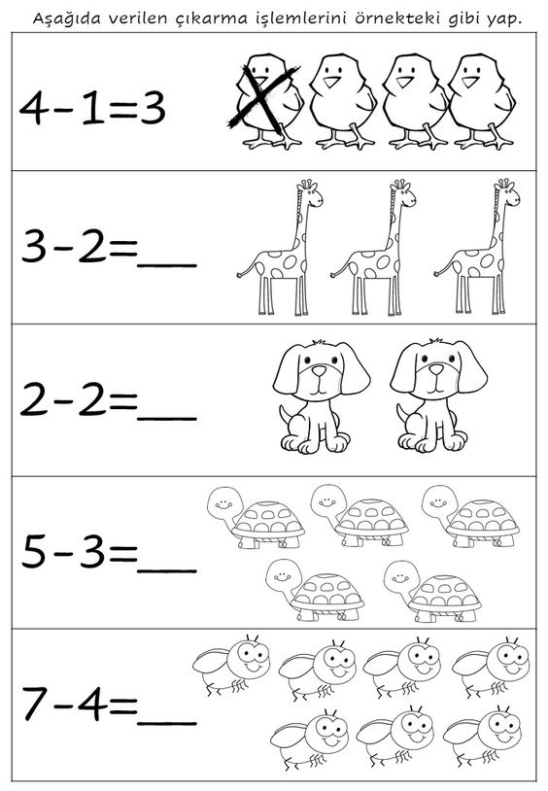
Slika preuzeta s: https://www.pinterest.com/pin/858498747728418292/

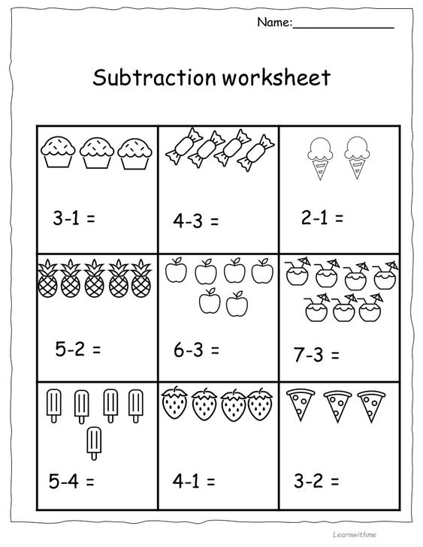
Slika preuzeta: https://www.pinterest.com/pin/3799980925476706/

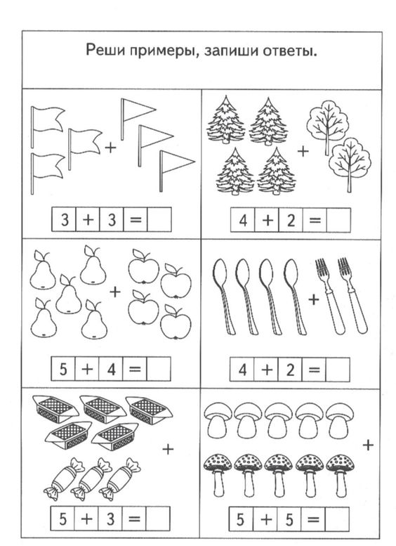

Slika preuzeta s: https://www.pinterest.com/pin/44895327519663108/
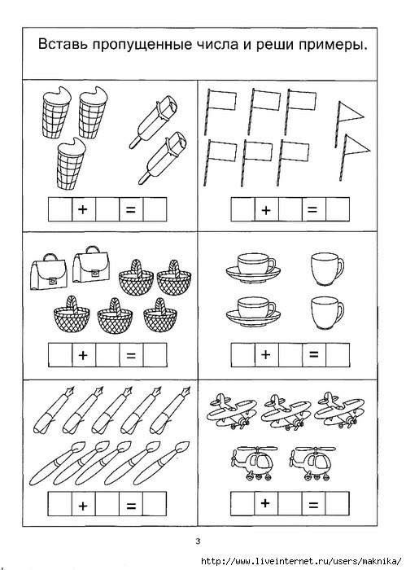
Slika preuzeta s: https://www.pinterest.com/pin/20407004552175833/

