ODGOJNO – OBRAZOVNO PODRUČJE: KOMUNIKACIJA
1. ZADATAK: POGLEDAJTE SLIKE, PROČITAJTE REČENICE I ISPRIČAJTE SVOJIM UKUĆANIMA PRIČU O RODI I ŽABI!
PRIČA „RODA I ŽABA“

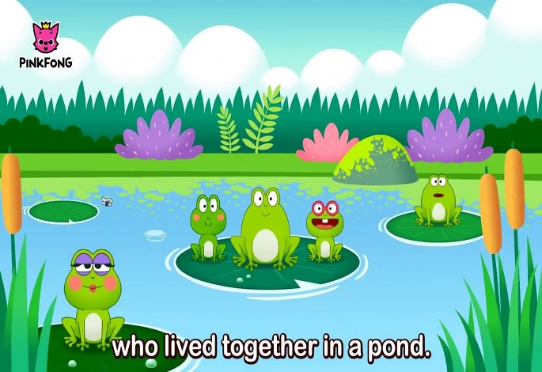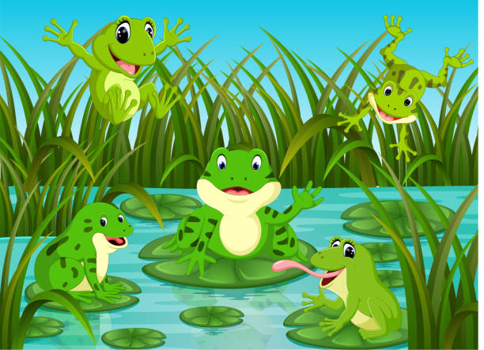
U JEDNOJ BARI ŽIVE ŽABE. ŽABE VESELO SKAČU I KREKEĆU.

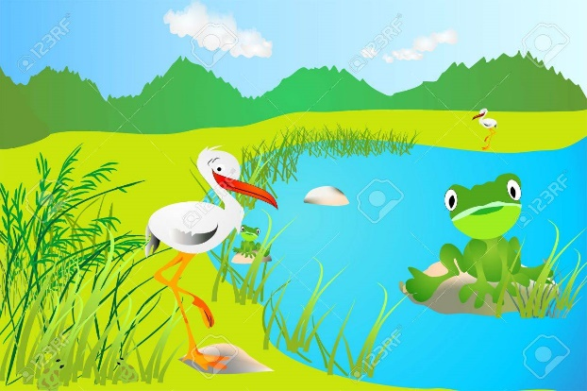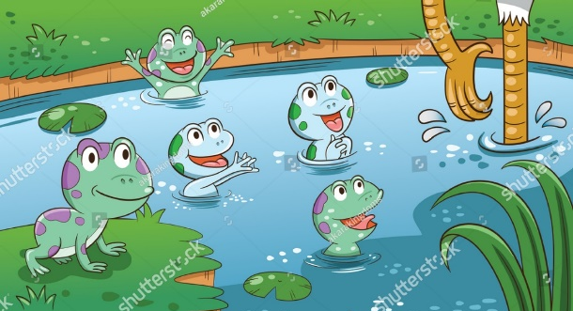
ŽABA ZELENKA UGLEDA RODU. RODA ULAZI U BARU.

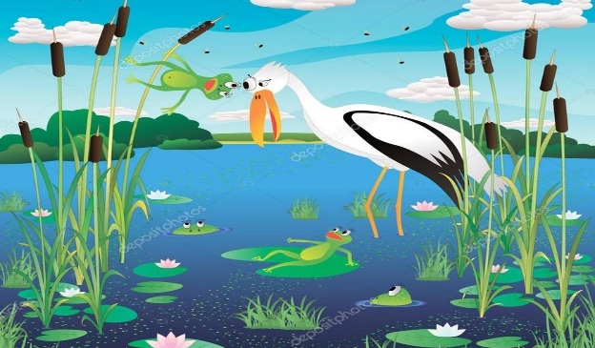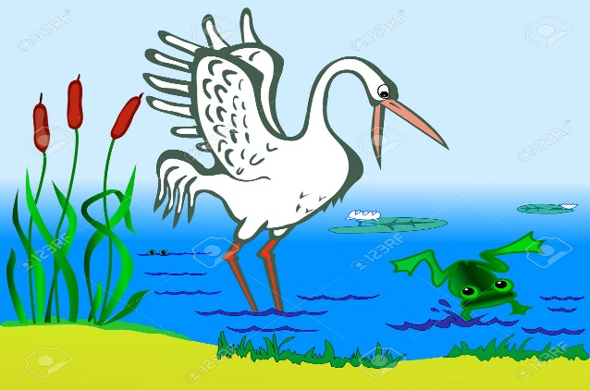
ŽABA ZELENKA SKAČE NA RODU. RODA SE NALJUTI I LOVI ŽABU.
2. ZADATAK: IZREŽITE SLIKE I REČENICE, ZALIJEPITE IH U BILJEŽNICU PO REDU!
ŽABA ZELENKA SKAČE NA RODU.
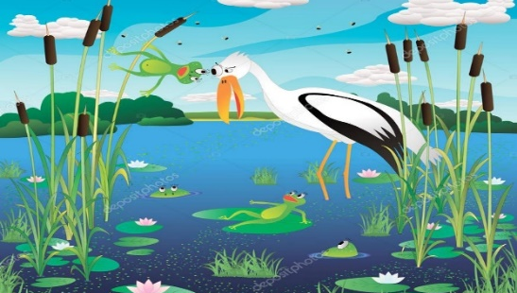
RODA ULAZI U BARU.
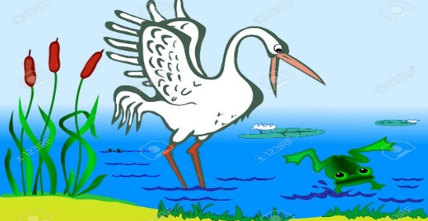
U JEDNOJ BARI ŽIVE ŽABE.
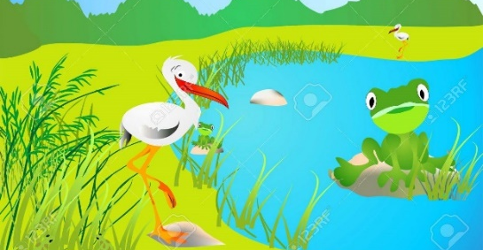
RODA SE NALJUTI I LOVI ŽABU.
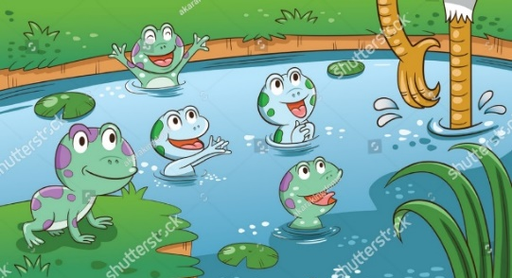
ŽABA ZELENKA UGLEDA RODU.
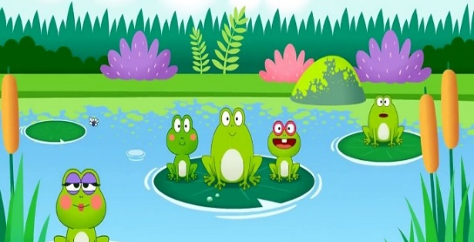
ŽABE VESELO SKAČU I KREKEĆU.

* Slike su uzete s internetskih stranica:
https://s1.dmcdn.net/v/MuCJm1QIlzWN2D0R0/x1080
https://previews.123rf.com/images/elunia/elunia1205/elunia120500059/13765777-cigogne-et-la-grenouille.jpg
https://media.istockphoto.com/vectors/many-frogs-on-leaf-with-river-scene-vector-id905051522?k=20&m=905051522&s=612x612&w=0&h=RZGSg43glr2IMu1xp1EkgcZX159RUx7w2Dp9FyeMvYE=
https://image.shutterstock.com/z/stock-vector-stork-and-frogs-in-the-jungle-pond-for-aesop-s-fables-the-frogs-who-desired-a-king-story-aspect-1518726146.jpg
https://st3.depositphotos.com/10116292/13051/v/950/depositphotos_130515628-stock-illustration-frog-and-heron-in-a.jpg
https://previews.123rf.com/images/alzam/alzam1203/alzam120300172/12770582-stork-and-frog-in-the-pond.jpg

