PRIRODA I DRUŠTVO PONEDJELJAK, 11.4.2022. SVI UČENICI
Prepoznaj životinju, napiši joj ime, što ona jede, zaokruži je li biljojed ili mesojed.

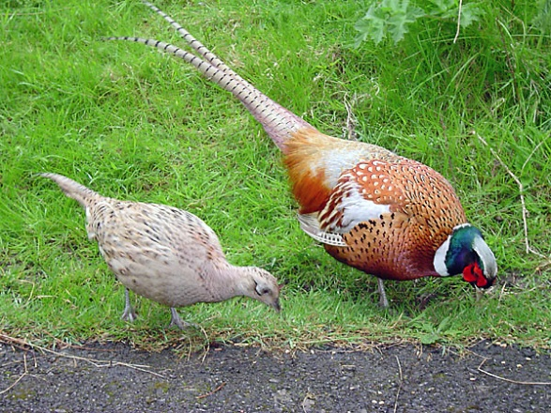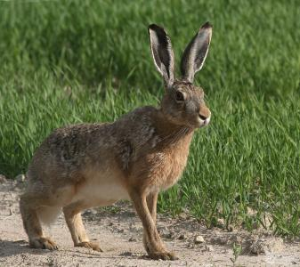
NAZIV ŽIVOTINJE:______________________ NAZIV ŽIVOTINJE:_______________________
PREHRANA:___________________________ PREHRANA:____________________________
_____________________________________ ______________________________________
BILJOJED ILI MESOJED BILJOJED ILI MESOJED

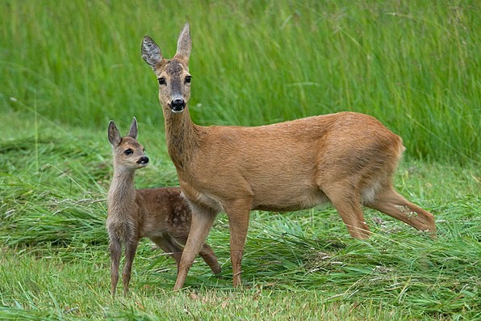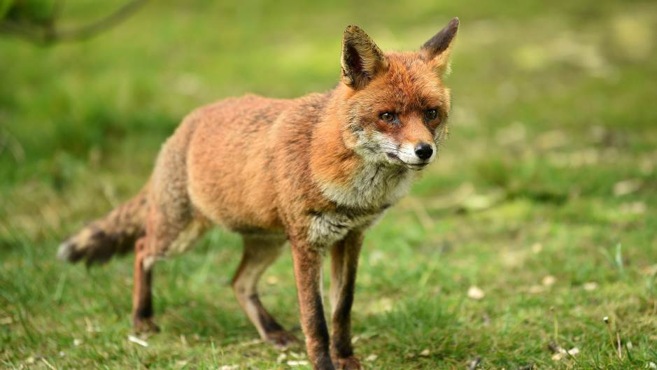
NAZIV ŽIVOTINJE:______________________ NAZIV ŽIVOTINJE:_______________________
PREHRANA:___________________________ PREHRANA:____________________________
_____________________________________ ______________________________________
BILJOJED ILI MESOJED BILJOJED ILI MESOJED

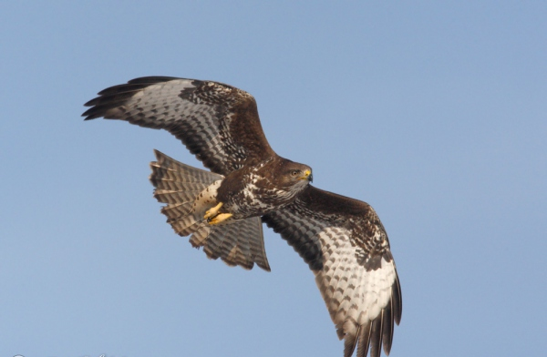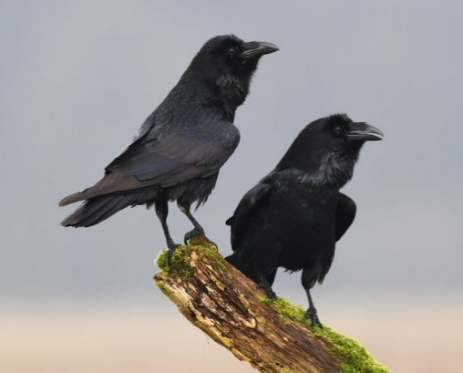
NAZIV ŽIVOTINJE:______________________ NAZIV ŽIVOTINJE:_______________________
PREHRANA:___________________________ PREHRANA:____________________________
_____________________________________ ______________________________________
BILJOJED ILI MESOJED BILJOJED ILI MESOJED
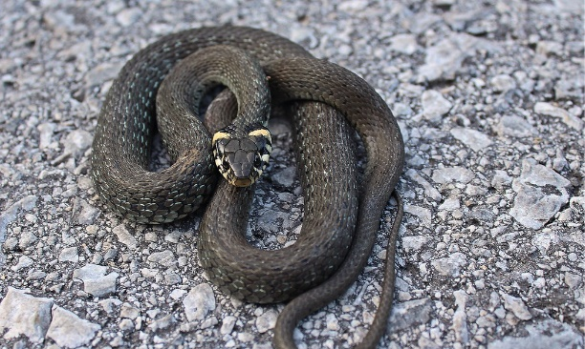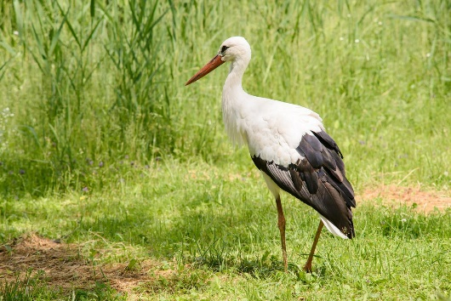
NAZIV ŽIVOTINJE:______________________ NAZIV ŽIVOTINJE:_______________________
PREHRANA:___________________________ PREHRANA:____________________________
_____________________________________ ______________________________________
BILJOJED ILI MESOJED BILJOJED ILI MESOJED
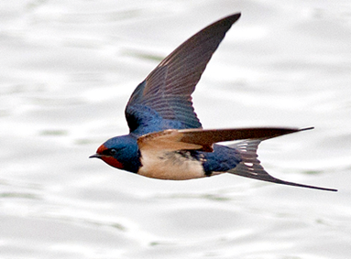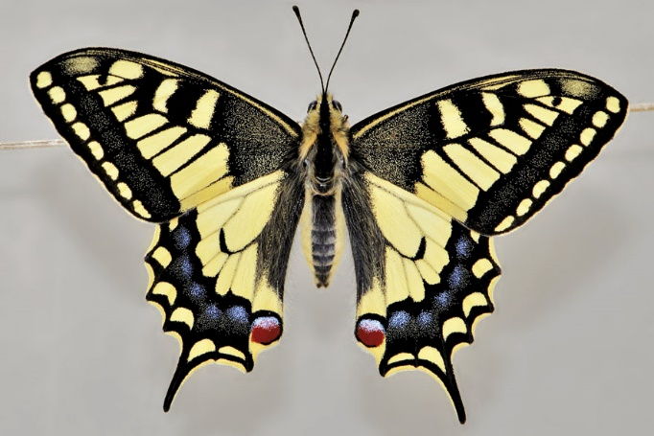
NAZIV ŽIVOTINJE:______________________ NAZIV ŽIVOTINJE:_______________________
PREHRANA:___________________________ PREHRANA:____________________________
_____________________________________ ______________________________________
BILJOJED ILI MESOJED BILJOJED ILI MESOJED

