

[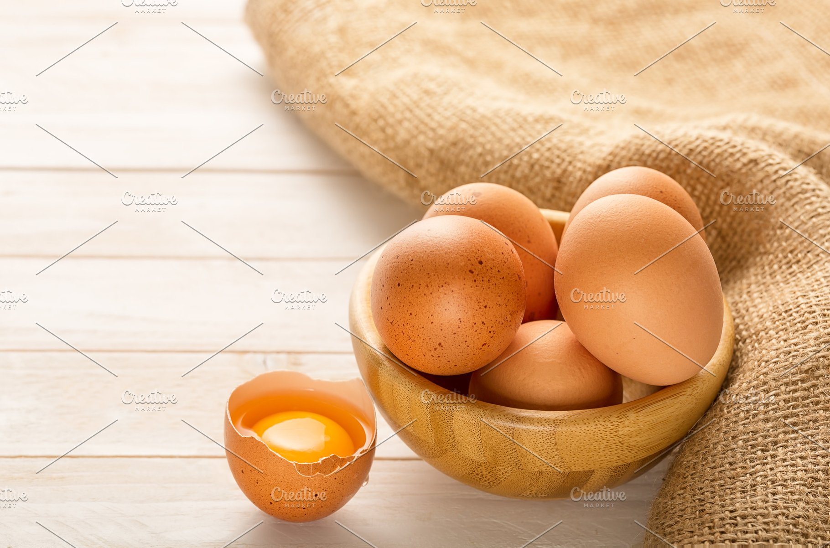](https://www.google.hr/url?sa=i&url=https://creativemarket.com/RodicaCiorba/3401556-Bowl-with-egs-on-white-wooden-backgr&psig=AOvVaw3xJWap69-DCO3OSpH-O-12&ust=1584610588228000&source=images&cd=vfe&ved=0CAIQjRxqFwoTCPDul83co-gCFQAAAAAdAAAAABAu)

nese

.

Koka nese jaja.

[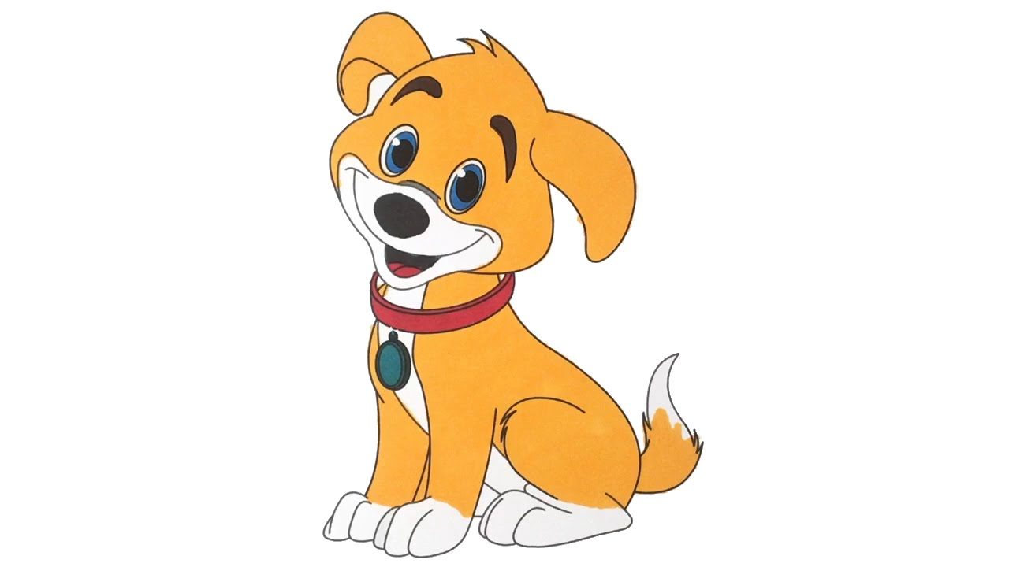](https://www.google.hr/url?sa=i&url=https://www.youtube.com/watch?v=hmqFksNBnPA&psig=AOvVaw3FEXxm6xVEYSInhVH1pDl1&ust=1584610937172000&source=images&cd=vfe&ved=0CAIQjRxqFwoTCPiAofPdo-gCFQAAAAAdAAAAABAI)



voli

.

Pas voli meso.









živi u

.

Sova živi u šumi.

gleda .

Roda gleda žabu.