[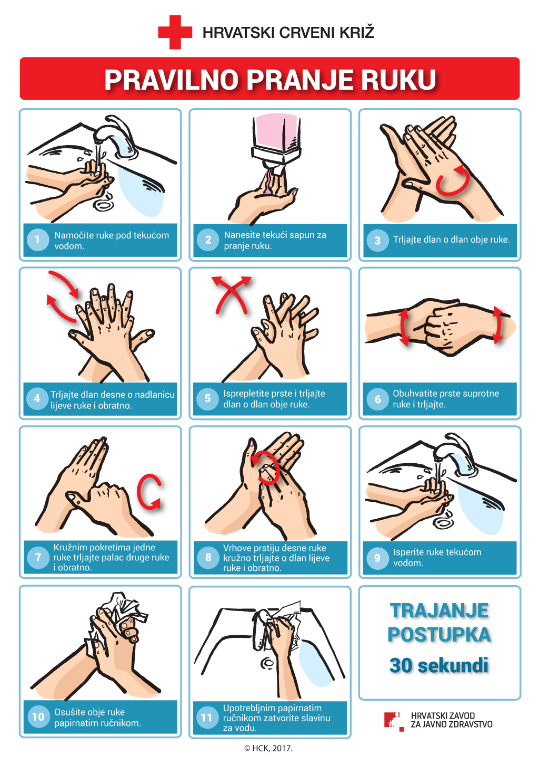](https://www.google.hr/url?sa=i&url=https://www.hzjz.hr/sluzba-zdravstvena-ekologija/pravilno-pranje-ruku/&psig=AOvVaw2nJnp0TfOMm_5kfvxbrgXv&ust=1585584516590000&source=images&cd=vfe&ved=0CAIQjRxqFwoTCIjX5uOIwOgCFQAAAAAdAAAAABAD)