**[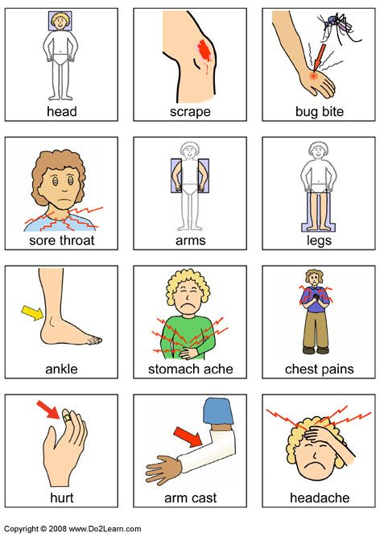](http://do2learn.com/picturecards/printandgo/fordoctors/whathurts.htm) [](http://do2learn.com/picturecards/printandgo/fordoctors/whathurts.htm)**

KAŠLJEM I KIŠEM

**[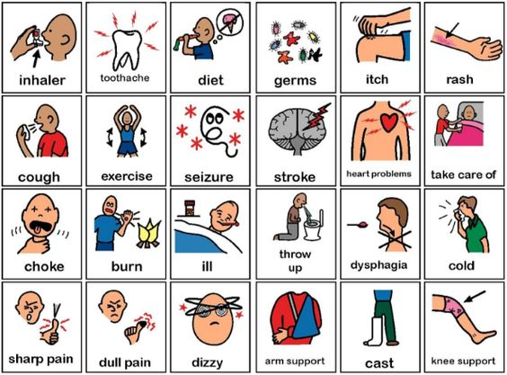](https://bsci21.org/pecs-precision-teaching/?uaid=pinterest)**

CURI MI NOS

**[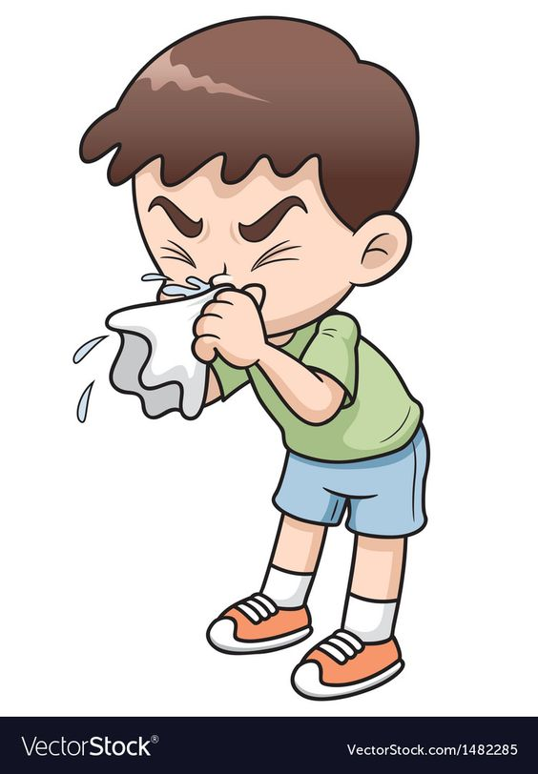](https://www.vectorstock.com/royalty-free-vector/sick-boy-cartoon-vector-1482285)**

**[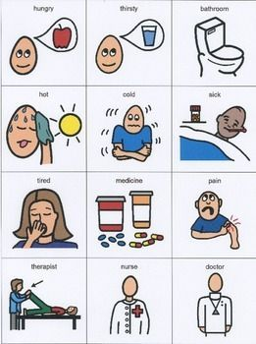](https://www.teacherspayteachers.com/Product/Basic-Needs-Communication-Board-1766562)**

BOLI ME GLAVA

BOLI ME GRLO

KADA SAM BOLESTAN NE OSJEĆAM SE DOBRO.

IMAM TEMPERATURU

KAKO SE PONAŠAM KADA SAM PREHLAĐEN?

UZ POMOĆ RODITELJA, POGLEDAJ SLIČICE I PROČITAJ REČENICE. SPOJI SLIKU NA LIJEVOJ STRANI S ODGOVARAJUĆOM REČENICOM NA DESNOJ.

**[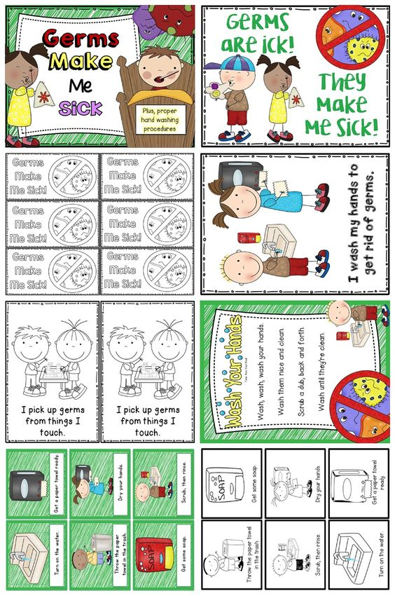](https://www.teacherspayteachers.com/Product/Germs-Make-Me-Sick-Plus-Hand-Washing-Procedures-504357)**

KADA KIŠEM I KAŠLJEM KORISTIM MARAMICU.

PEREM RUKE REDOVITO.

**[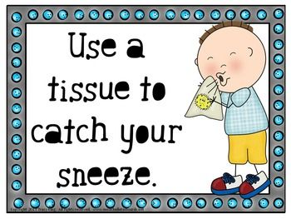](https://www.teacherspayteachers.com/Product/Lets-Be-Germ-Free-Bulletin-Board-1036653)**

**[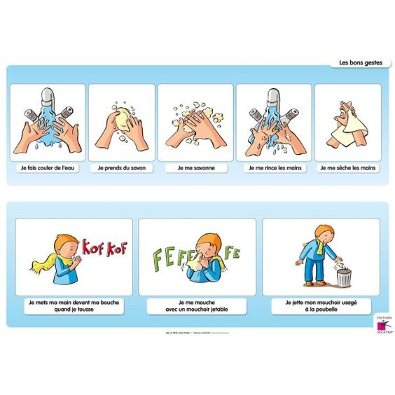](https://jocatop.fr/decouvrir-le-monde/47-de-la-tete-aux-pieds-9782917742181.html)**

AKO IMAM TEMPERATURU LEŽIM U KREVETU. PIJEM ČAJ I LIJEKOVE.

[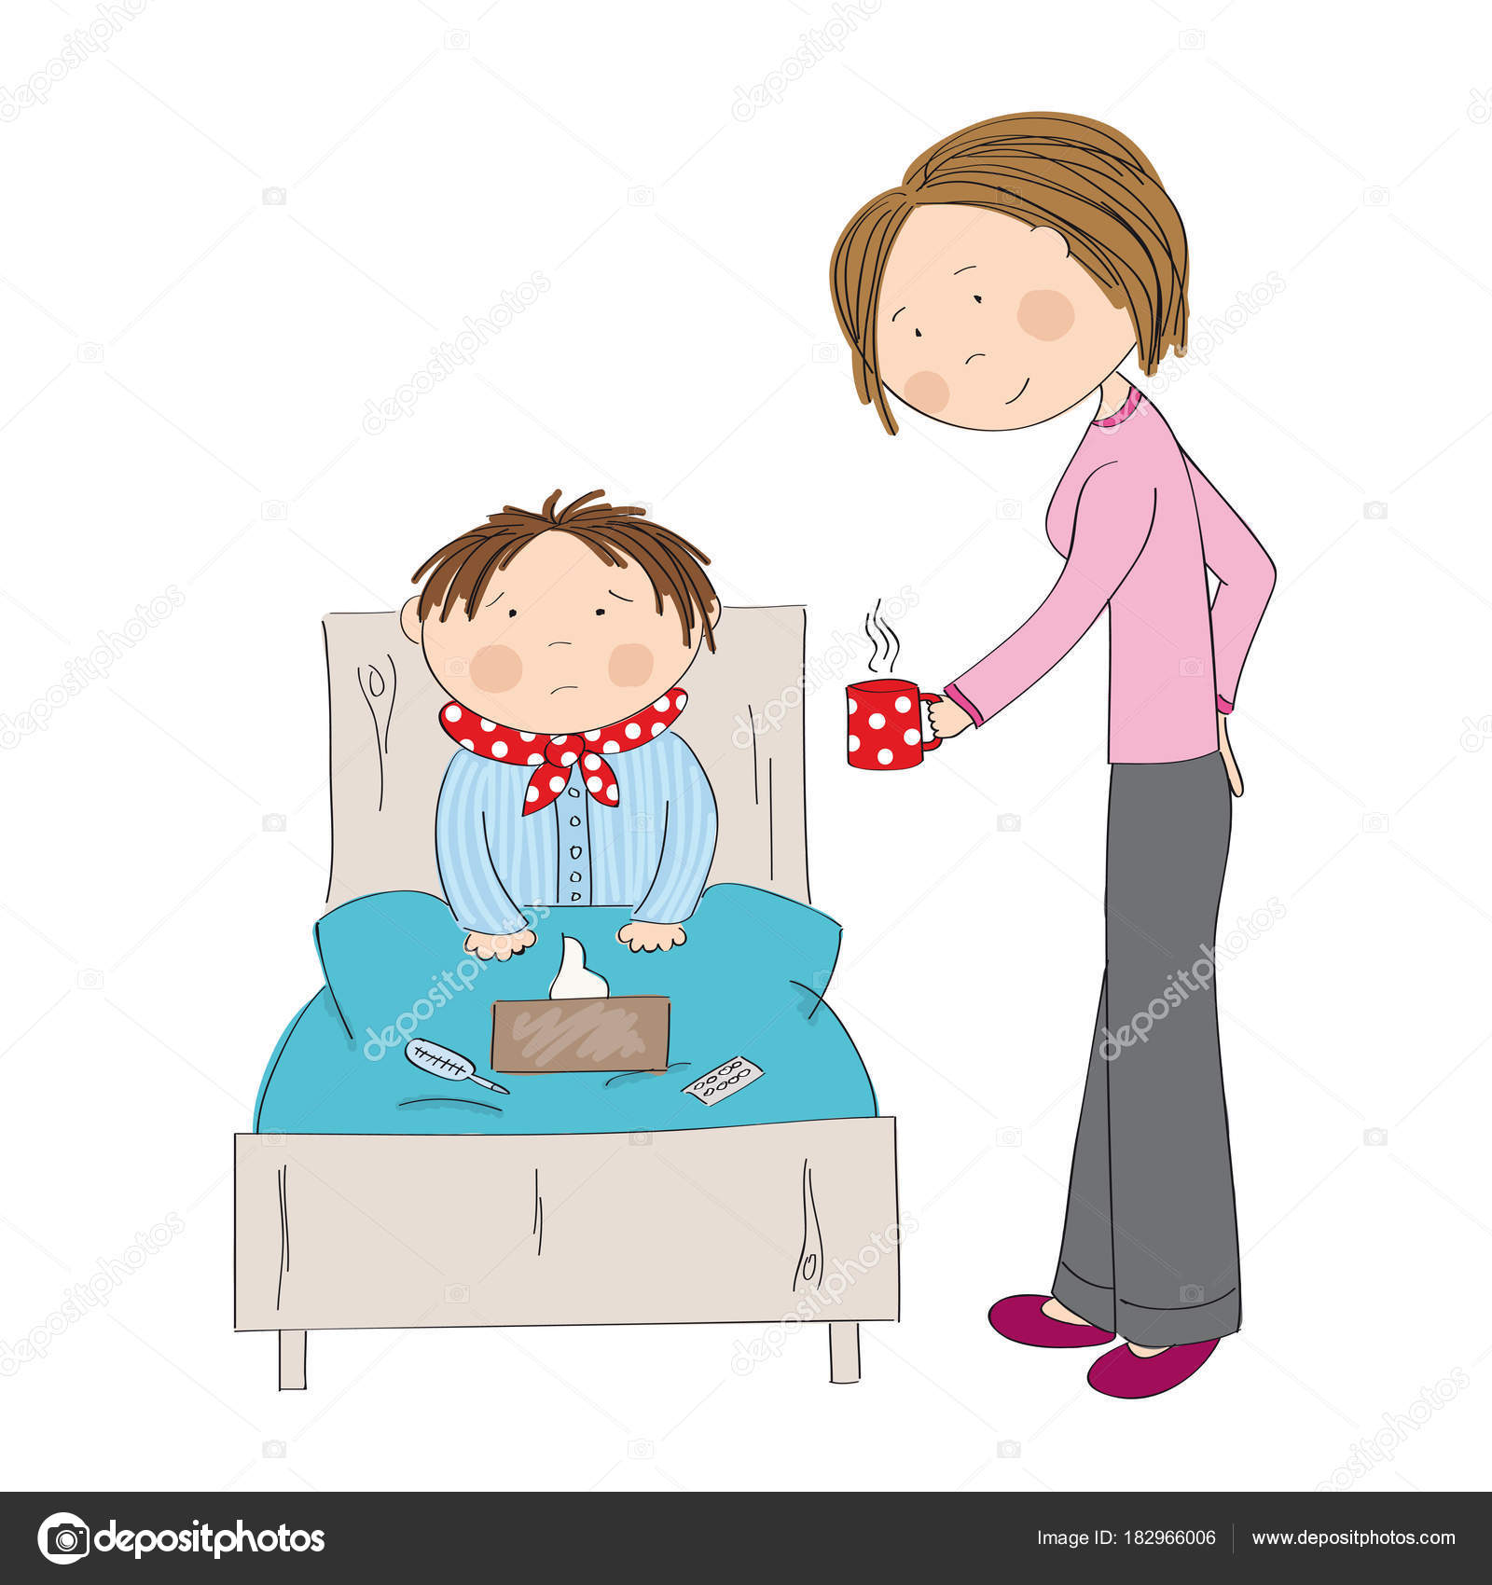](https://www.google.hr/url?sa=i&rct=j&q=&esrc=s&source=images&cd=&ved=&url=https://depositphotos.com/182966006/stock-illustration-sick-boy-with-flu-sitting.html&psig=AOvVaw00Tfz-Yz0rki-o85Cm5GEw&ust=1574710607669077)

BRIŠEM NOS U MARAMICU.

MARAMICU BACAM U KOŠ.