[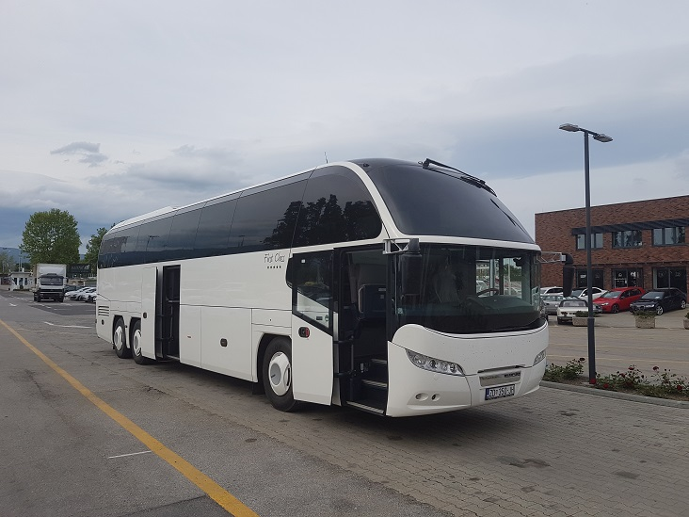](https://www.google.hr/url?sa=i&url=http%3A%2F%2Ftransfer-punta.com%2Fvozila%2Fponuda%2Fnajam%2Bautobusa&psig=AOvVaw0tWT6o338K46YDimuTCdiQ&ust=1585768691369000&source=images&cd=vfe&ved=0CAIQjRxqFwoTCLDQo721xegCFQAAAAAdAAAAABAD)

**AUTOBUS**

**[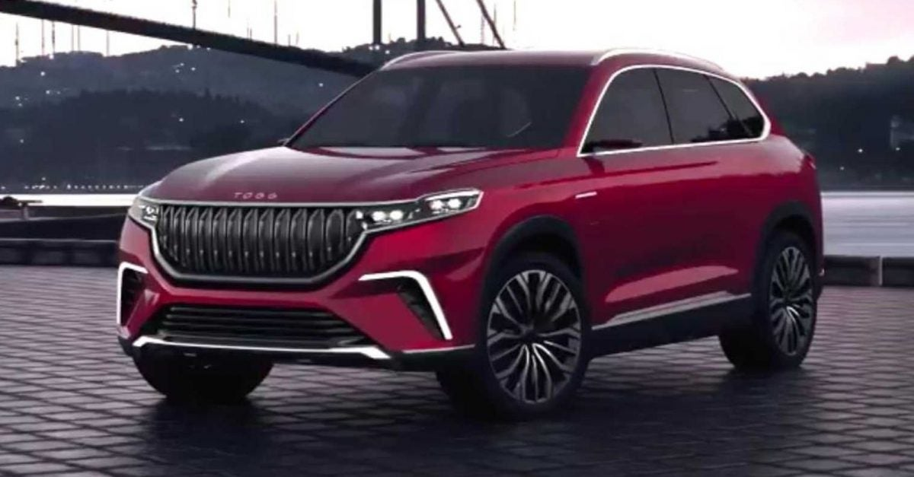](https://www.google.hr/url?sa=i&url=https%3A%2F%2Fwww.mobilegeeks.de%2Fnews%2Ftogg-erdogan-stellt-das-erste-tuerkische-e-auto-vor%2F&psig=AOvVaw2tJ_EKd3T993e4bQa2ovur&ust=1585768782401000&source=images&cd=vfe&ved=0CAIQjRxqFwoTCNiDtfG1xegCFQAAAAAdAAAAABAJ)**

**AUTOMOBIL**

**[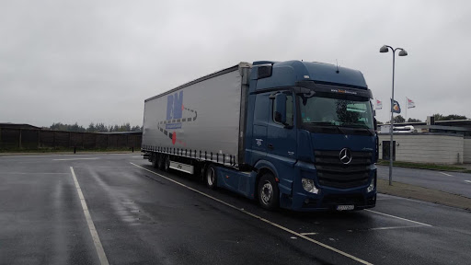](https://www.google.hr/url?sa=i&url=http%3A%2F%2Flme-ltrans.hr%2F&psig=AOvVaw2Qom-mqs72f2EnqtjkPgP3&ust=1585768873774000&source=images&cd=vfe&ved=0CAIQjRxqFwoTCJjl9bm2xegCFQAAAAAdAAAAABAD)**

**KAMION**

**[](https://www.google.hr/url?sa=i&url=https%3A%2F%2Fwww.zutiklik.hr%2Ffiksni-telefoni&psig=AOvVaw3bZkuOMQrSMfGlvydcxUEk&ust=1585769098158000&source=images&cd=vfe&ved=0CAIQjRxqFwoTCKCbgYi3xegCFQAAAAAdAAAAABAE)[](https://www.google.hr/url?sa=i&url=https%3A%2F%2Fwww.nezavisne.com%2Fnauka-tehnologija%2Fgadgets%2FDa-li-ce-fiksni-telefon-prezivjeti-tehnoloski-bum%2F347141&psig=AOvVaw3bZkuOMQrSMfGlvydcxUEk&ust=1585769098158000&source=images&cd=vfe&ved=0CAIQjRxqFwoTCKCbgYi3xegCFQAAAAAdAAAAABAQ)**

**FIKSNI TELEFON**

**[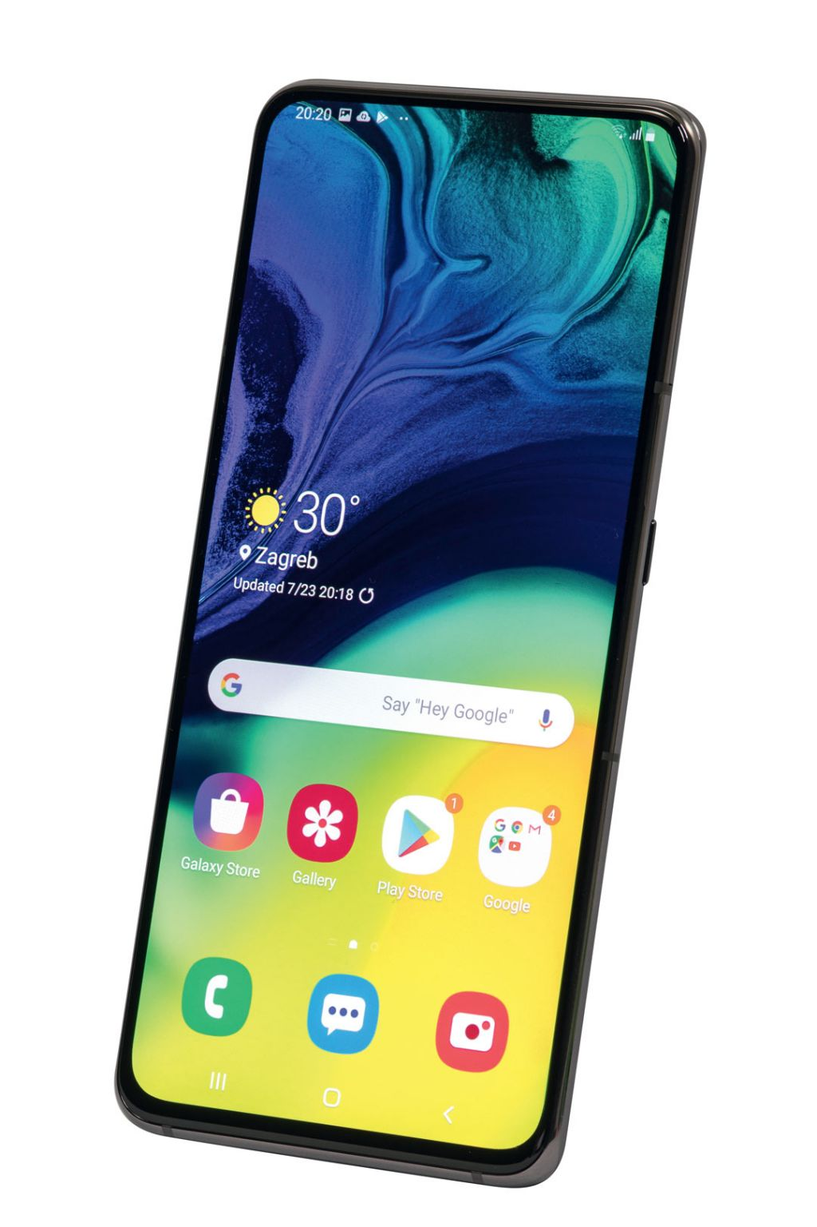](https://www.google.hr/url?sa=i&url=https%3A%2F%2Fwww.vidilab.com%2Fhardver%2Fmobil%2Fpametni-telefon%2F4494-samsung-galaxy-a80&psig=AOvVaw3bZkuOMQrSMfGlvydcxUEk&ust=1585769098158000&source=images&cd=vfe&ved=0CAIQjRxqFwoTCKCbgYi3xegCFQAAAAAdAAAAABAg)MOBITEL**