trči u

Zeko trči u šumu.

[](https://www.google.hr/url?sa=i&url=https://de.freepik.com/vektoren-premium/cartoon-wald-hintergrund_3317365.htm&psig=AOvVaw1j-6IWr6DjQf_DVDhiuufa&ust=1585857016900000&source=images&cd=vfe&ved=0CAIQjRxqFwoTCOiVuoCAyOgCFQAAAAAdAAAAABAD)

[](https://www.google.hr/url?sa=i&url=https://www.abeka.com/abekaonline/mediadescription.aspx?id=0000205788&psig=AOvVaw3ghRkfs0iviLjvXcxV4pEN&ust=1585856815350000&source=images&cd=vfe&ved=0CAIQjRxqFwoTCMCsqaj_x-gCFQAAAAAdAAAAABAR)

drži

[](https://www.google.hr/url?sa=i&url=https://www.123rf.com/photo_73614937_stock-vector-human-cartoon-hand-showing-five-fingers-or-a-waving-gesture.html&psig=AOvVaw0CAwYlKb7mDvwcu7uQjcv1&ust=1585857342679000&source=images&cd=vfe&ved=0CAIQjRxqFwoTCKDa6ZKByOgCFQAAAAAdAAAAABAD)

[](https://www.google.hr/url?sa=i&url=https://www.123rf.com/photo_81520886_stock-vector-cartoon-image-of-basket-icon-basket-symbol.html&psig=AOvVaw3bCKL9vVaHrnZ9T7hiN4qv&ust=1585857441597000&source=images&cd=vfe&ved=0CAIQjRxqFwoTCLCT4cGByOgCFQAAAAAdAAAAABAJ)

U

uuuuuuuuuuuuuuu

U ruci drži košaru.

U [](https://www.google.hr/url?sa=i&url=https://www.123rf.com/photo_81520886_stock-vector-cartoon-image-of-basket-icon-basket-symbol.html&psig=AOvVaw3bCKL9vVaHrnZ9T7hiN4qv&ust=1585857441597000&source=images&cd=vfe&ved=0CAIQjRxqFwoTCLCT4cGByOgCFQAAAAAdAAAAABAJ) su .

[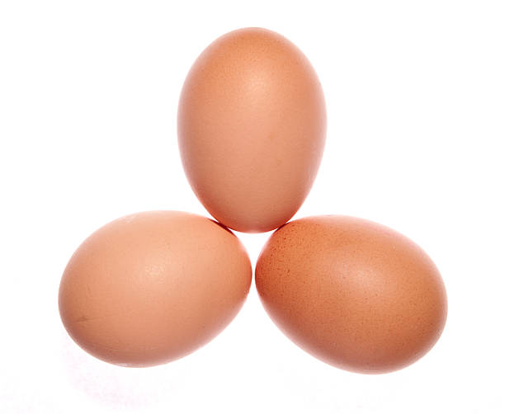](https://www.google.hr/url?sa=i&url=https://www.istockphoto.com/photos/egs&psig=AOvVaw16u0Q2DFjeQI7jZhK5rAPH&ust=1585857666271000&source=images&cd=vfe&ved=0CAIQjRxqFwoTCMCxsKqCyOgCFQAAAAAdAAAAABAD)

U košari su jaja.