[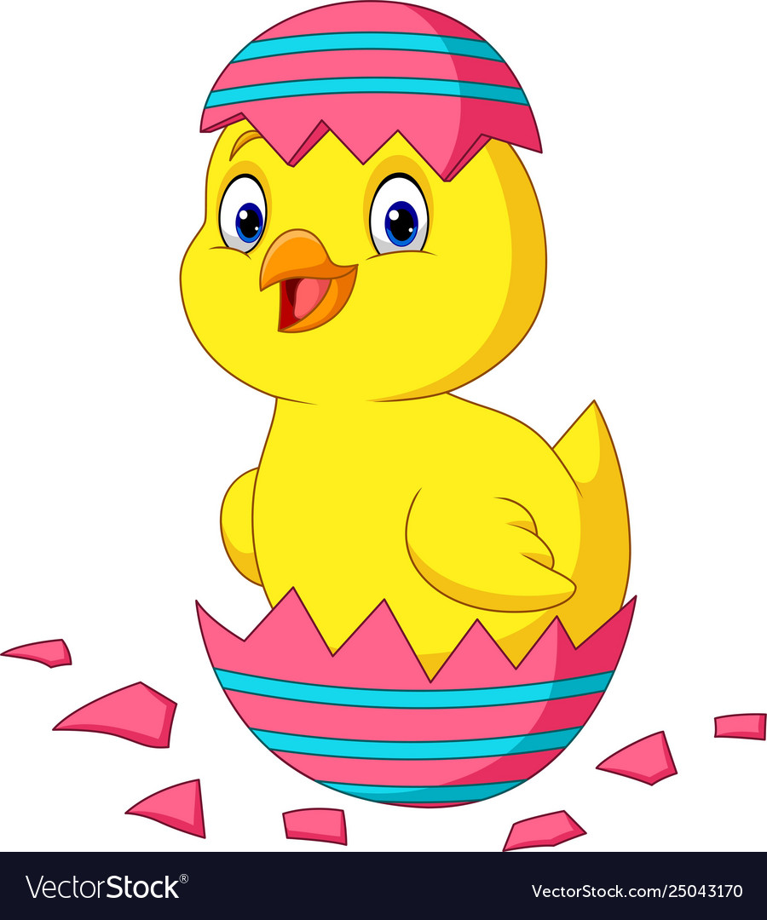](https://www.google.hr/url?sa=i&url=https://www.vectorstock.com/royalty-free-vector/cartoon-little-chick-hatching-from-an-easter-egg-vector-25043170&psig=AOvVaw0K-sahF7LBbpma_jfEdavd&ust=1586290987169000&source=images&cd=vfe&ved=0CAIQjRxqFwoTCIDa5MrQ1OgCFQAAAAAdAAAAABAi)

[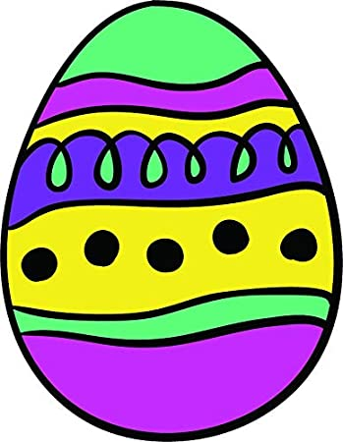](https://www.google.hr/url?sa=i&url=https://www.amazon.com/Colorful-Cartoon-Sticker-Rainbow-Pattern/dp/B07JLVPZCR&psig=AOvVaw2O_G_a4KbI1qfo3CM_81fL&ust=1586290814844000&source=images&cd=vfe&ved=0CAIQjRxqFwoTCLCR7frP1OgCFQAAAAAdAAAAABAe)

[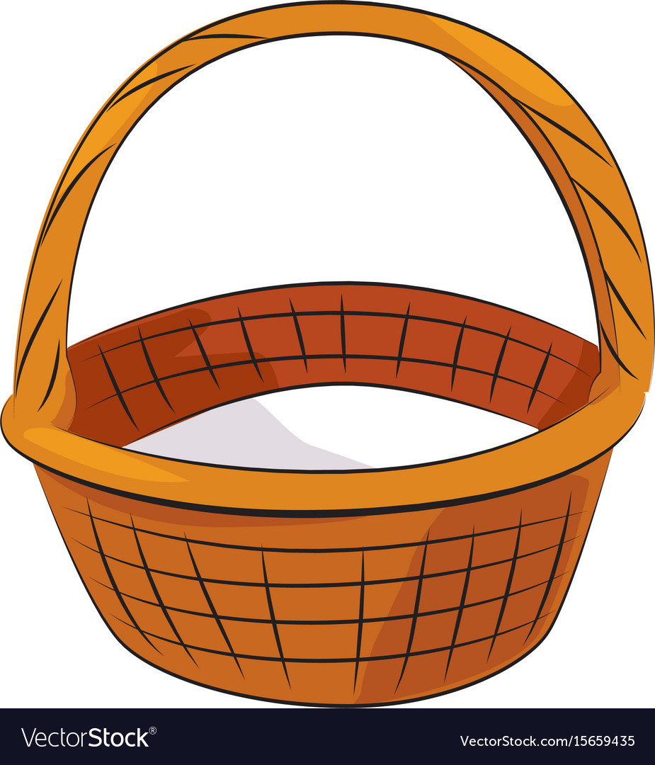](https://www.google.hr/url?sa=i&url=https://www.vectorstock.com/royalty-free-vector/cartoon-image-of-basket-icon-basket-symbol-vector-15659435&psig=AOvVaw1P6lZf1Jie0HR4KxjsEfGD&ust=1586290883714000&source=images&cd=vfe&ved=0CAIQjRxqFwoTCNiQ-5nQ1OgCFQAAAAAdAAAAABAI)

[](https://www.google.hr/url?sa=i&url=https://www.shutterstock.com/search/bunny+cartoon&psig=AOvVaw2Ghz8SpPwsUoeGUKGgNkMx&ust=1586290733197000&source=images&cd=vfe&ved=0CAIQjRxqFwoTCJj49dHP1OgCFQAAAAAdAAAAABAD)

zec

košara

pisanica

pilić

Koji blagdan slavimo? Pokaži i imenuj.

[](https://www.google.hr/url?sa=i&url=https://www.walmart.com/ip/GODPOK-Valentine-s-Day-Two-People-in-Love-Holding-Hands-Cartoon-Children-s-Drawing-Series-See-More-Images-Rug-Doormat-Bath-Mat-23-6x15-7-inch/229949206&psig=AOvVaw1EaFbg6NelF3IYLQdLihuT&ust=1586291264017000&source=images&cd=vfe&ved=0CAIQjRxqFwoTCPj1g9LR1OgCFQAAAAAdAAAAABAO) [](https://www.google.hr/url?sa=i&url=https://www.clipart.email/clipart/christmas-tree-clipart-67.html&psig=AOvVaw2RD1AZgIOJ42FlLLwWjoXY&ust=1586291357745000&source=images&cd=vfe&ved=0CAIQjRxqFwoTCPi95f3R1OgCFQAAAAAdAAAAABAO) [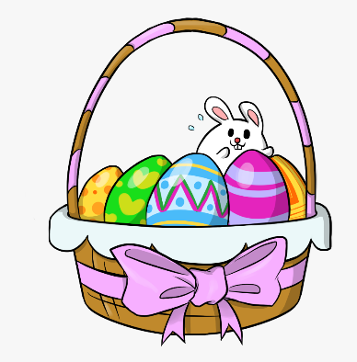](https://www.google.hr/url?sa=i&url=https://www.netclipart.com/isee/ooTJh_free-to-use-public-domain-easter-baskets-clip/&psig=AOvVaw3NB-o2KvGYsZLSh2m21wYA&ust=1586291548987000&source=images&cd=vfe&ved=0CAIQjRxqFwoTCLjL89_S1OgCFQAAAAAdAAAAABAP)

USKRS

BOŽIĆ

VALENTINOVO