**PRIMJERI USKRŠNJIH VAZICA OD PLASTIČNIH / STAKLENIH BOCA**

[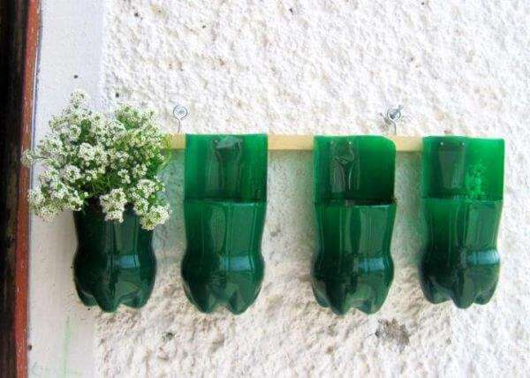](https://www.google.hr/url?sa=i&url=https://www.diyoldthings.com/garden/7-recycled-bottle-planters/&psig=AOvVaw24_RRjnjoQ7pN-Ibr1HYvs&ust=1586412902596000&source=images&cd=vfe&ved=0CAIQjRxqFwoTCLjqlYCX2OgCFQAAAAAdAAAAABAK) 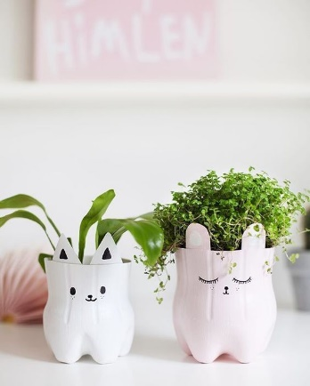 [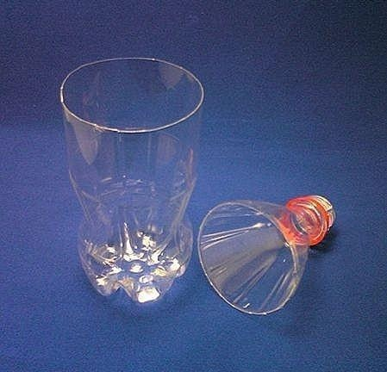](https://www.google.hr/url?sa=i&url=https://wonderfuldiy.com/wonderful-diy-woven-plastic-bottle-vase/&psig=AOvVaw24_RRjnjoQ7pN-Ibr1HYvs&ust=1586412902596000&source=images&cd=vfe&ved=0CAIQjRxqFwoTCLjqlYCX2OgCFQAAAAAdAAAAABAQ)

[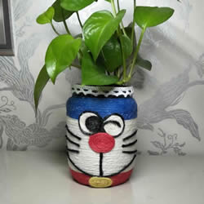](https://www.google.hr/url?sa=i&url=https://www.kidscanmake.com/craft/How-to-Make-a-Vase-with-Plastic-Bottle-Step-by-Step-183.html&psig=AOvVaw3FxvPJLXhuNgtjEhGffqFT&ust=1586413094561000&source=images&cd=vfe&ved=0CAIQjRxqFwoTCMDM5sCX2OgCFQAAAAAdAAAAABAF) 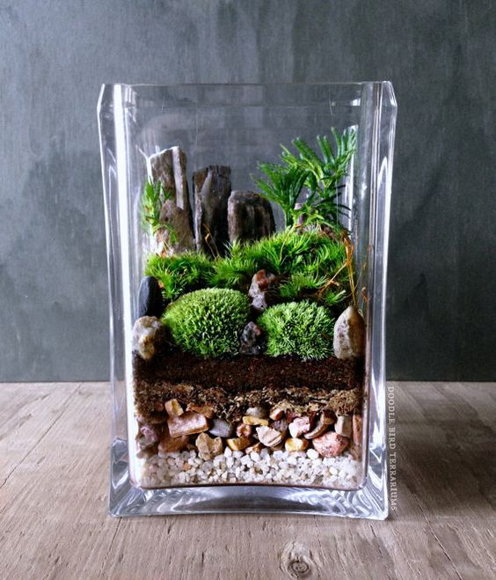 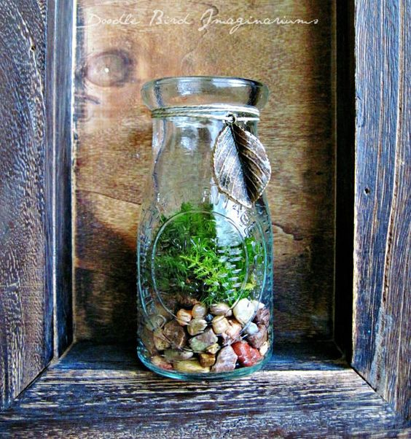

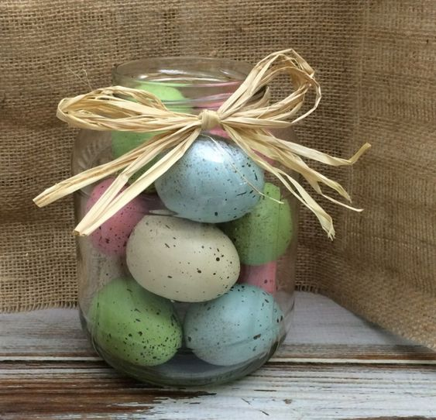 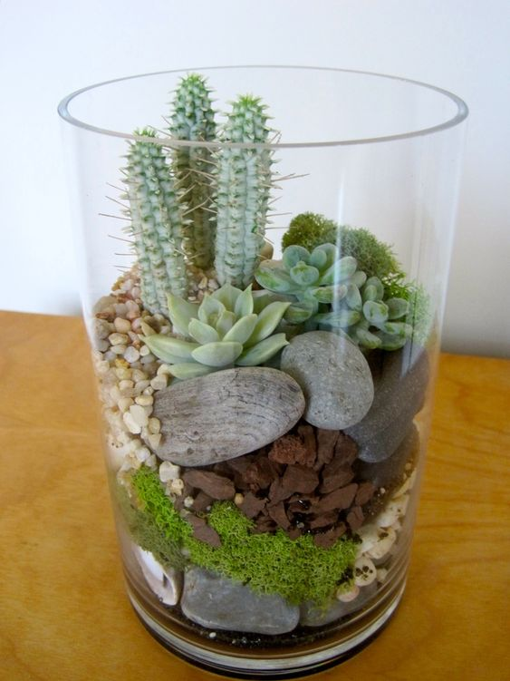 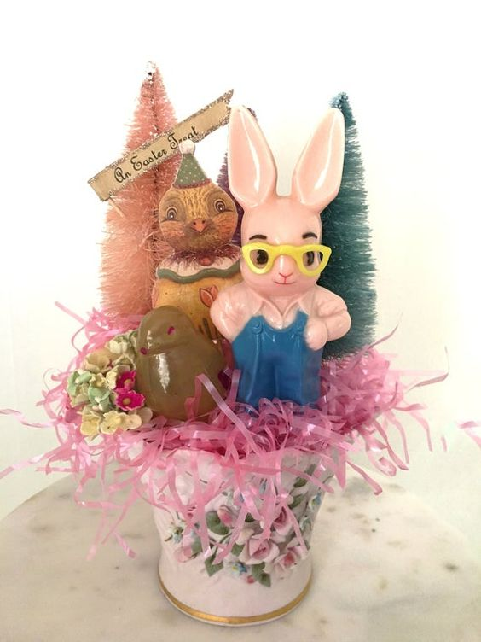

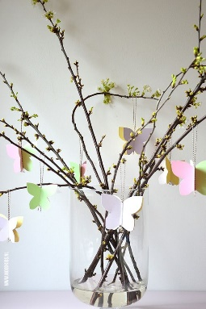 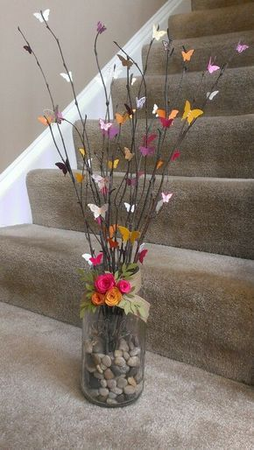 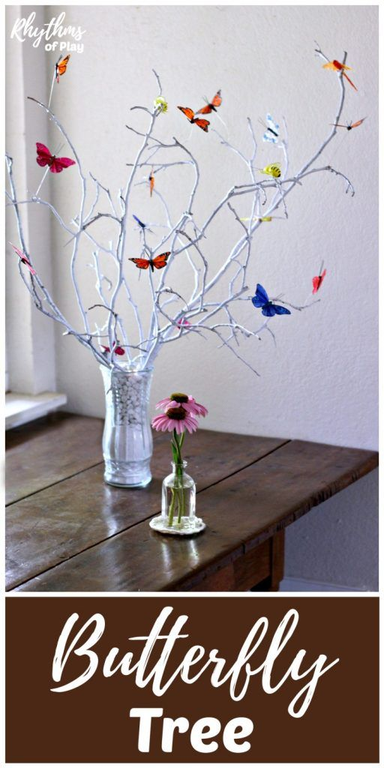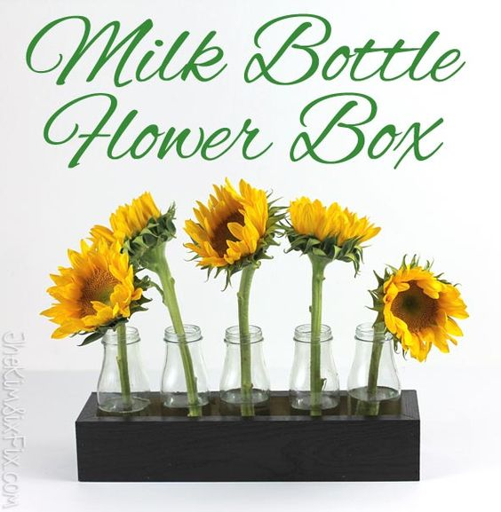

FOTOGRAFIJE PREUZETE SA PINTEREST WEB STRANICE