[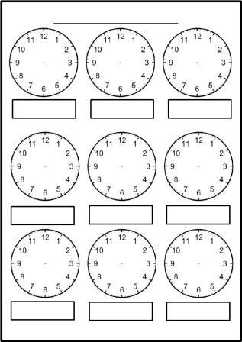](https://www.google.hr/url?sa=i&url=https://www.pinterest.com/pin/703757879242757827/&psig=AOvVaw00P26rMuOlYNYfHL026OL7&ust=1586412320301000&source=images&cd=vfe&ved=0CAIQjRxqFwoTCIi2vMmU2OgCFQAAAAAdAAAAABAD)