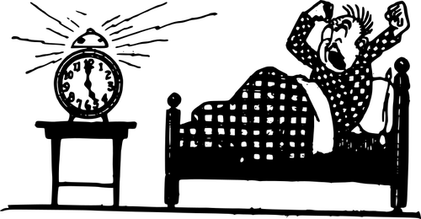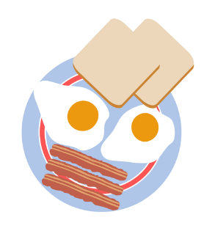

JUTRO - DORUČAK

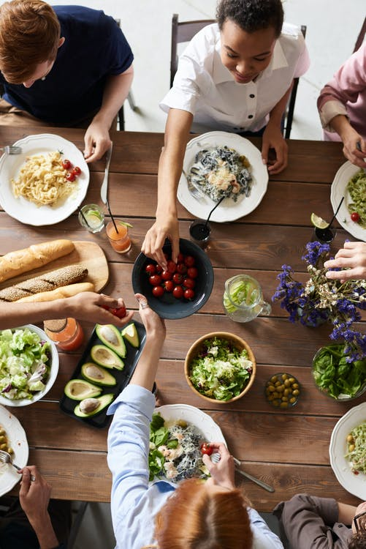
PODNE - RUČAK

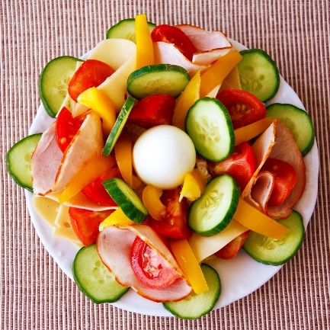
VEČER - VEČERA
Clipart korišten sa stranice publicdomainvectors.org:
https://publicdomainvectors.org/en/free-clipart/Waking-up/45860.html
https://publicdomainvectors.org/en/free-clipart/Eggs-with-toast-and-bacon/36654.html

Korištene fotografije s pexels.com:
fauxels

Korištene fotografije s pixabay.com:
PublicDomainPictures

