Postupak slaganja hlača

[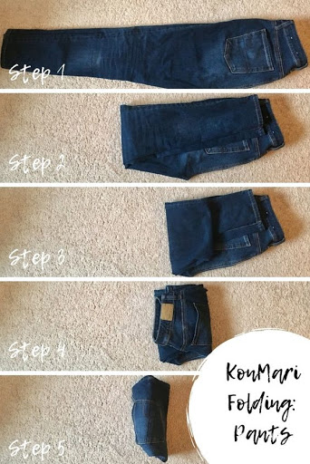](https://www.google.hr/url?sa=i&url=http://www.foliver.com/diy/clothes-folding-hacks/&psig=AOvVaw2GCya7p_d-I69FC99fwWLS&ust=1586971977238000&source=images&cd=vfe&ved=0CAIQjRxqFwoTCKjV0b256OgCFQAAAAAdAAAAABAO)