Pogledaj sliku i reci što vidiš. U svoju bilježnicu napiši prvo slovo kojim počinje ime predmeta/ bića na slici. Možeš si nacrtati kvadratiće kao što su na listiću ispod slika.

Uz pomoć roditelja /udomitelja pročitaj rečenicu i još je jednom napiši u bilježnicu.

[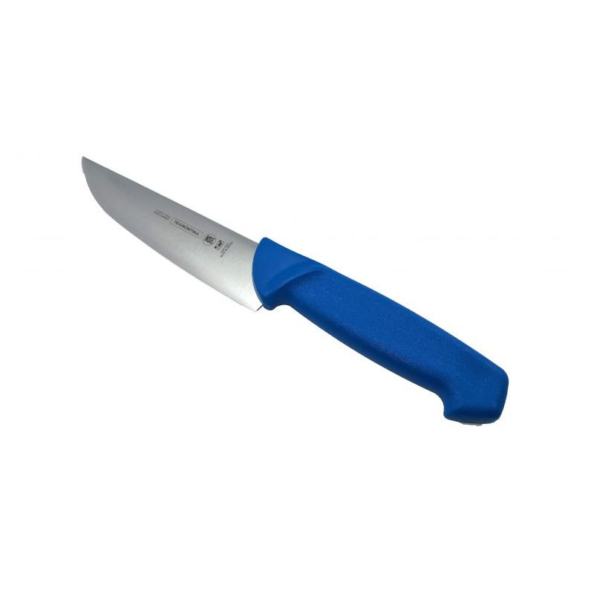](https://www.google.hr/url?sa=i&url=https://profiagro.hr/shop/cijena/mesarski-noz-tramontina-24621-016&psig=AOvVaw1vDpbsofr-EyTSYpiMyzQ0&ust=1587153778519000&source=images&cd=vfe&ved=0CAIQjRxqFwoTCNjxqd7e7egCFQAAAAAdAAAAABAD)

[](https://www.google.hr/url?sa=i&url=https://www.angieslist.com/companylist/us/fl/new-port-richey/tru-line-electric-reviews-7348914.htm&psig=AOvVaw2at1Afe-OWiLIWZg9C-DW5&ust=1587153536700000&source=images&cd=vfe&ved=0CAIQjRxqFwoTCPDP4e3d7egCFQAAAAAdAAAAABAI)[](https://www.google.hr/url?sa=i&url=https://www.kissclipart.com/inuit-clip-art-clipart-eskimo-inuit-clip-art-k50ofh/&psig=AOvVaw3mHSQ9ZSG1CpMGqHnELHj7&ust=1587153480181000&source=images&cd=vfe&ved=0CAIQjRxqFwoTCOi1itHd7egCFQAAAAAdAAAAABAJ)



[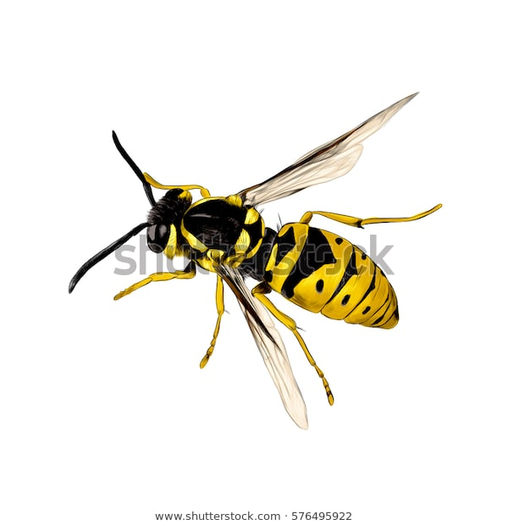](https://www.google.hr/url?sa=i&url=https://www.shutterstock.com/pt/image-vector/wasp-insect-vector-color-drawing-576495922&psig=AOvVaw1m05FCDFYFkH52-fcY64ik&ust=1587153608307000&source=images&cd=vfe&ved=0CAIQjRxqFwoTCPD9v4_e7egCFQAAAAAdAAAAABAm)



[](https://www.google.hr/url?sa=i&url=https://www.kissclipart.com/inuit-clip-art-clipart-eskimo-inuit-clip-art-k50ofh/&psig=AOvVaw3mHSQ9ZSG1CpMGqHnELHj7&ust=1587153480181000&source=images&cd=vfe&ved=0CAIQjRxqFwoTCOi1itHd7egCFQAAAAAdAAAAABAJ)

[](https://www.google.hr/url?sa=i&url=https://www.kissclipart.com/inuit-clip-art-clipart-eskimo-inuit-clip-art-k50ofh/&psig=AOvVaw3mHSQ9ZSG1CpMGqHnELHj7&ust=1587153480181000&source=images&cd=vfe&ved=0CAIQjRxqFwoTCOi1itHd7egCFQAAAAAdAAAAABAJ)

[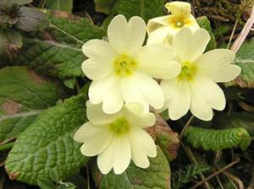](https://www.google.hr/url?sa=i&url=https://www.kucacajamakarska.com/shop/ljekovito-bilje/jaglac/&psig=AOvVaw31aDUV1B3XZFsLQ7cY5PRG&ust=1587153716664000&source=images&cd=vfe&ved=0CAIQjRxqFwoTCPi7zMDe7egCFQAAAAAdAAAAABAD)





[](https://www.google.hr/url?sa=i&url=https://www.angieslist.com/companylist/us/fl/new-port-richey/tru-line-electric-reviews-7348914.htm&psig=AOvVaw2at1Afe-OWiLIWZg9C-DW5&ust=1587153536700000&source=images&cd=vfe&ved=0CAIQjRxqFwoTCPDP4e3d7egCFQAAAAAdAAAAABAI)







