[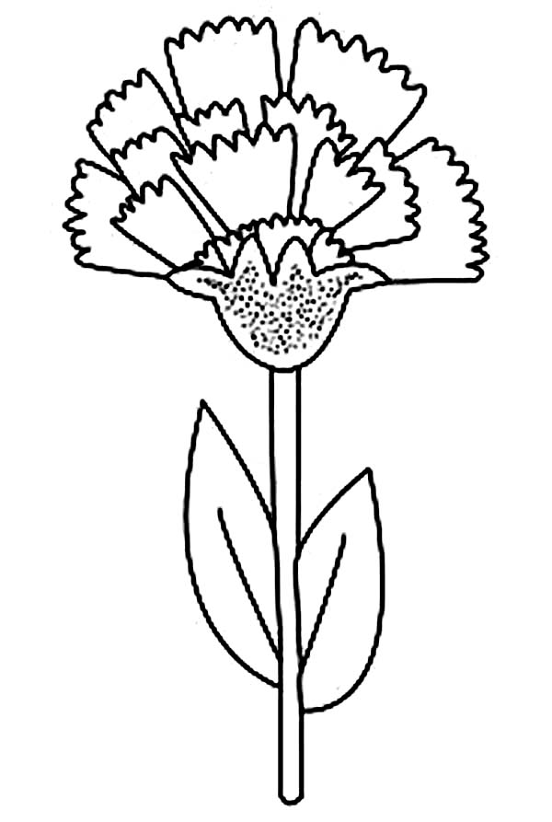](https://www.google.hr/url?sa=i&url=https://www.coloringsun.com/ohio-state-flower-carnation-coloring-page/&psig=AOvVaw1zf2qJwcHG7kOYCozgOMCR&ust=1588187876956000&source=images&cd=vfe&ved=0CAIQjRxqFwoTCNiplYjri-kCFQAAAAAdAAAAABAJ)

**KARANFIL**