**PRUGA**

[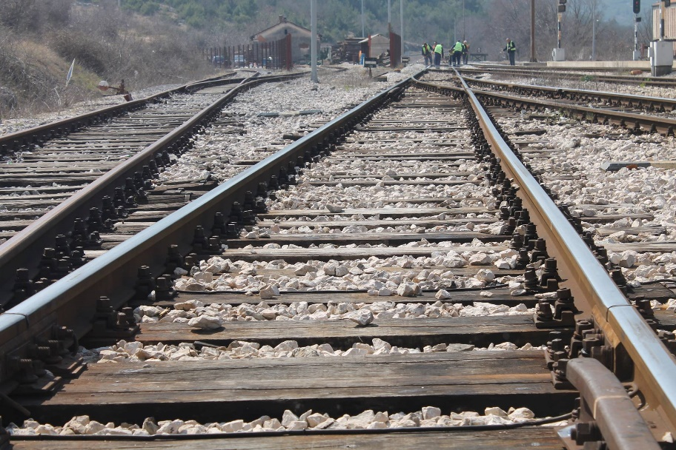](https://www.google.hr/url?sa=i&url=https://www.sibenik.in/crna-kronika/istovremeno-se-pokvarili-vlak-i-rampa-na-Pruzi-u-krickama-promet-normaliziran/96848.html&psig=AOvVaw27PCxtefXSKImBPtnGtodb&ust=1588659891128000&source=images&cd=vfe&ved=0CAIQjRxqFwoTCMja2rrJmekCFQAAAAAdAAAAABAG)[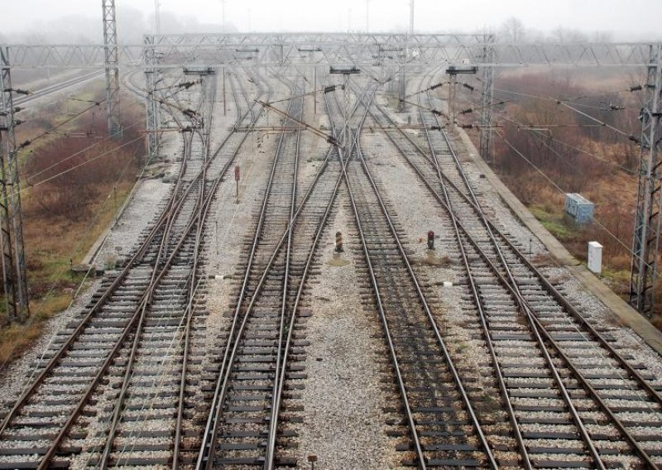](https://www.google.hr/url?sa=i&url=https://www.tportal.hr/tag/zeljeznicka-pruga-dugo-selo-krizevci&psig=AOvVaw39YhZPmfRg_eF24uW7jsNQ&ust=1588659967840000&source=images&cd=vfe&ved=0CAIQjRxqFwoTCKjziN3JmekCFQAAAAAdAAAAABAP)

[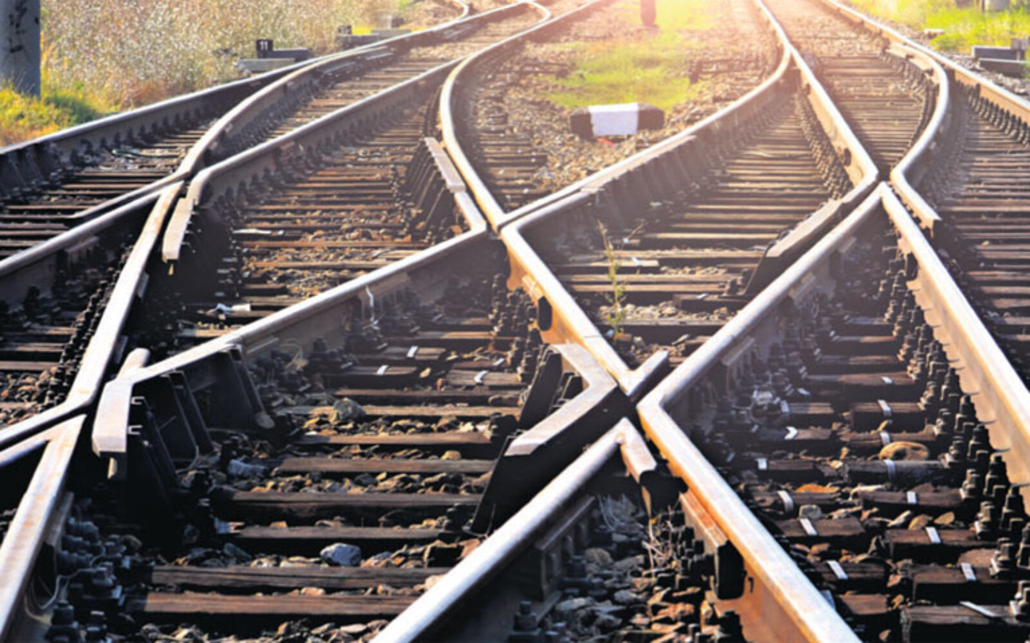](https://www.google.hr/url?sa=i&url=https://www.poslovni.hr/svijet/brza-pruga-preko-nisa-spajat-ce-beograd-s-lukom-pirej-360574&psig=AOvVaw39YhZPmfRg_eF24uW7jsNQ&ust=1588659967840000&source=images&cd=vfe&ved=0CAIQjRxqFwoTCKjziN3JmekCFQAAAAAdAAAAABAD)

[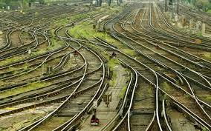](https://www.google.hr/url?sa=i&url=http://energis.ba/velika-britanija-solarne-elektrane-uz-sve-zeljeznicke-pruge/&psig=AOvVaw0G2A6JTDkYhseah9DlgQgF&ust=1588660051761000&source=images&cd=vfe&ved=0CAIQjRxqFwoTCNCqh4nKmekCFQAAAAAdAAAAABAE)