**[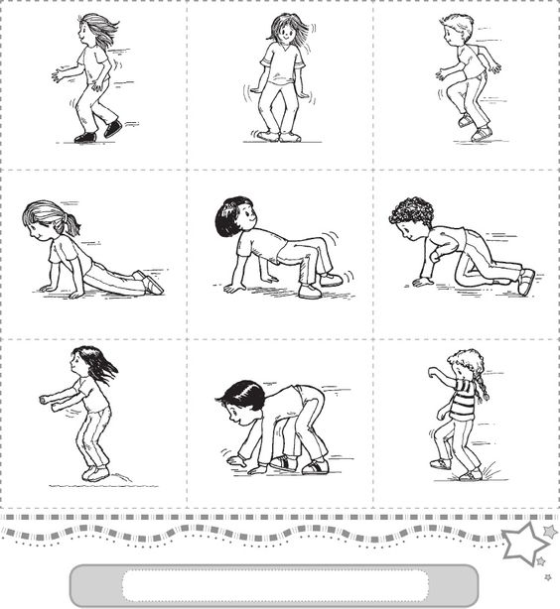](http://www.scribd.com/mobile/doc/91910031)**hod [](https://www.google.hr/url?sa=i&url=https://www.vectorstock.com/royalty-free-vector/penguins-vector-10628763&psig=AOvVaw1w8gi7nrQ_My6ttAIrpZH1&ust=1585682695131000&source=images&cd=vfe&ved=0CAIQjRxqFwoTCICpt8n2wugCFQAAAAAdAAAAABA-)

**[](http://www.scribd.com/mobile/doc/91910031)**

[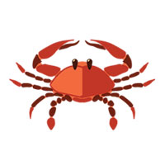](https://www.google.hr/url?sa=i&url=https://www.astroloskicentar.com/horoskop/rak/nedeljni/&psig=AOvVaw3BCb8dgB70IZoxfbiys035&ust=1585683046371000&source=images&cd=vfe&ved=0CAIQjRxqFwoTCKiKuuz3wugCFQAAAAAdAAAAABAS)

hod

**[](http://www.scribd.com/mobile/doc/91910031)** hod

[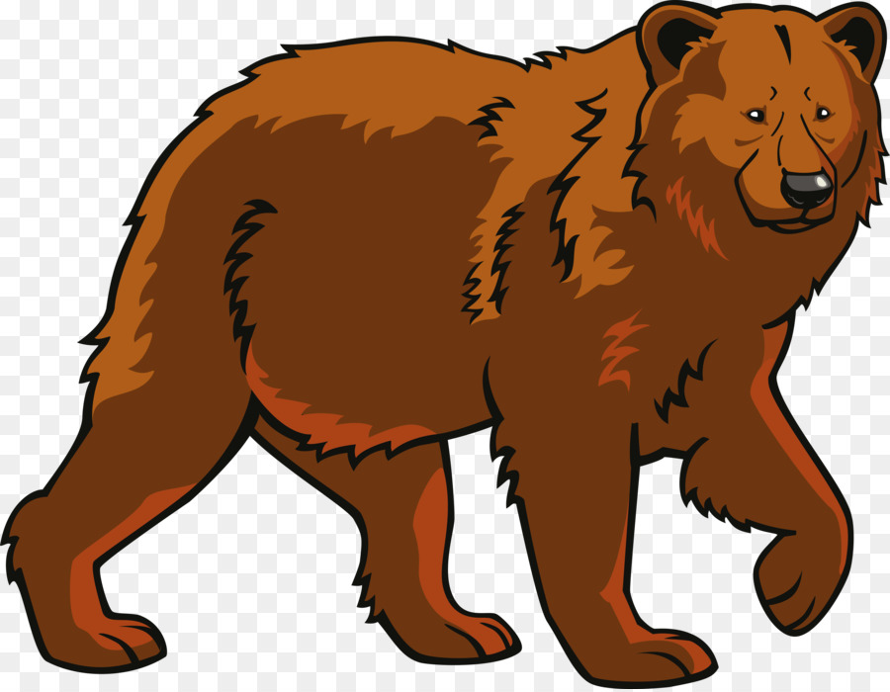](https://www.google.hr/url?sa=i&url=https://www.cleanpng.com/png-polar-bear-eurasian-brown-bear-clip-art-bear-627397/&psig=AOvVaw3ipQtNSuXsqxt35BLvltfh&ust=1585684469798000&source=images&cd=vfe&ved=0CAIQjRxqFwoTCPDS8pP9wugCFQAAAAAdAAAAABAD)

**[](http://www.scribd.com/mobile/doc/91910031)** skok

[](https://www.google.hr/url?sa=i&url=https://www.pinterest.com/pin/406731410084000322/&psig=AOvVaw2zn6Djbl4WRTKQbP2MYtm3&ust=1585684426112000&source=images&cd=vfe&ved=0CAIQjRxqFwoTCPDBk_38wugCFQAAAAAdAAAAABAD)