**OTPAD – STARI PAPIR**

[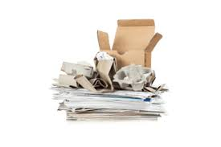](https://www.google.hr/imgres?imgurl=https%3A%2F%2Frcco.hr%2Fwp-content%2Fuploads%2F2016%2F12%2Fpapir.jpg&imgrefurl=https%3A%2F%2Frcco.hr%2Fpapir%2F&tbnid=PJdIEJ-NbY-HhM&vet=10CAMQxiAoAGoXChMImLPzvN-c6QIVAAAAAB0AAAAAEAY..i&docid=VeMAzUbv70r9iM&w=600&h=400&itg=1&q=recikliranje%20papira&ved=0CAMQxiAoAGoXChMImLPzvN-c6QIVAAAAAB0AAAAAEAY)[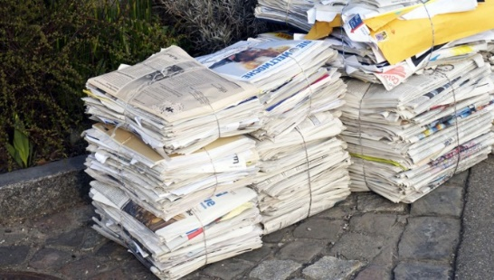](https://www.google.hr/url?sa=i&url=http%3A%2F%2Fwww.h-alter.org%2Fvijesti%2Ftajna-veza-bicikla-i-papira&psig=AOvVaw15JZKmgQj8hc2scMM7g7L_&ust=1588768877895000&source=images&cd=vfe&ved=0CAIQjRxqFwoTCJiz87zfnOkCFQAAAAAdAAAAABAJ)

**SAKUPLJAMO I BACAMO U**



**PLAVI KONTEJNER ZA PAPIR,**

**IZ NJIH SE SKUPLJA KAMIONIMA I VOZI U**



**TVORNICE GDJE SE PONOVNO PRERAĐUJE**



**KROZ PROCES PROIZVODNJE/ RECIKLIRANJA U**

[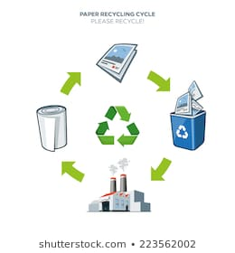](https://www.google.hr/url?sa=i&url=https%3A%2F%2Fwww.shutterstock.com%2Fimage-vector%2Flife-cycle-paper-recycling-simplified-scheme-223562002&psig=AOvVaw15JZKmgQj8hc2scMM7g7L_&ust=1588768877895000&source=images&cd=vfe&ved=0CAIQjRxqFwoTCJiz87zfnOkCFQAAAAAdAAAAABBg)

**NOVE PROIZVODE: NOVINE, BILJEŽNICE, TOALET PAPIR, KARTON.**

**[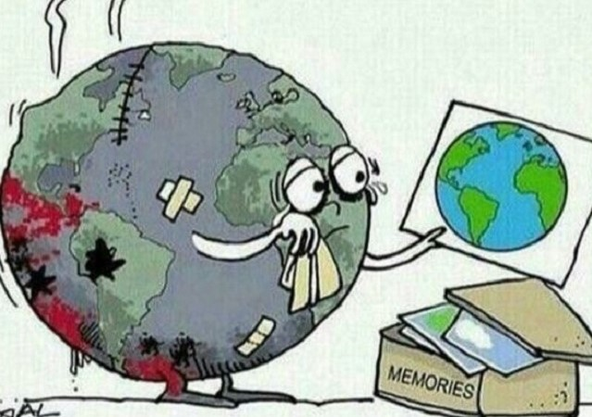](https://www.google.hr/url?sa=i&url=https%3A%2F%2Fstudentski.hr%2Fzabava%2Fzanimljivosti%2Fkako-reciklirati-i-sto-jos-mozes-kao-pojedinac-napraviti-za-spas-okolisa&psig=AOvVaw15JZKmgQj8hc2scMM7g7L_&ust=1588768877895000&source=images&cd=vfe&ved=0CAIQjRxqFwoTCJiz87zfnOkCFQAAAAAdAAAAABBl)**

**TO JE VAŽNO ZA OČUVANJE OKOLIŠA NA PLANETI ZEMLJI I NAŠEG ZDRAVLJA.**