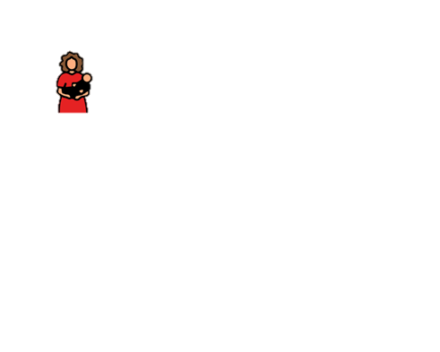

Majčine

[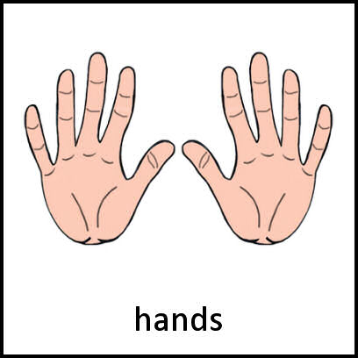](https://www.google.hr/url?sa=i&url=http://www.mypecs.com/pecs_382/hands.aspx&psig=AOvVaw3HZsPQ5D3Xfe4aPSfX_my6&ust=1588707959622000&source=images&cd=vfe&ved=0CAIQjRxqFwoTCID-vcf8mukCFQAAAAAdAAAAABAD)

ruke

Pala je [](https://www.google.hr/url?sa=i&url=https://www.amazon.com/Laeacco-Photography-Background-Mysterious-Children/dp/B075F4FFJZ&psig=AOvVaw1J1cQDtyTb1J5QRcPtXl3y&ust=1588708292521000&source=images&cd=vfe&ved=0CAIQjRxqFwoTCPCQiOf9mukCFQAAAAAdAAAAABAT) .

Na [](https://www.google.hr/url?sa=i&url=https://www.vectorstock.com/royalty-free-vector/window-cartoon-symbol-icon-design-vector-24007212&psig=AOvVaw2g-12WjC8vP-TrJSs9Ncax&ust=1588708507437000&source=images&cd=vfe&ved=0CAIQjRxqFwoTCNjCzsj-mukCFQAAAAAdAAAAABAJ) sjedi [](https://www.google.hr/url?sa=i&url=http://clipart-library.com/cartoon-moon-cliparts.html&psig=AOvVaw3Ks9rCB7UkQX1gOS30uWkL&ust=1588708573736000&source=images&cd=vfe&ved=0CAIQjRxqFwoTCPC1yeb-mukCFQAAAAAdAAAAABAD) .

Iz [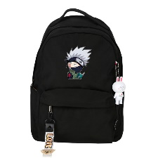](https://www.google.hr/url?sa=i&url=https://www.aliexpress.com/item/Hot-Japanese-NARUTO-Uchiha-Sasuke-Hatake-Kakashi-Cosplay-Men-Backpack-Anime-School-Bags-Nylon-Laptop-Backpack/32994045688.html&psig=AOvVaw3WyC6m_d-6IN9eU-ujbLNb&ust=1588708629049000&source=images&cd=vfe&ved=0CAIQjRxqFwoTCODpo4D_mukCFQAAAAAdAAAAABAU) vire mu bajke.

Netko me pokriva,

Jeli to [](https://www.google.hr/url?sa=i&url=http://clipart-library.com/cartoon-moon-cliparts.html&psig=AOvVaw3Ks9rCB7UkQX1gOS30uWkL&ust=1588708573736000&source=images&cd=vfe&ved=0CAIQjRxqFwoTCPC1yeb-mukCFQAAAAAdAAAAABAD) ili [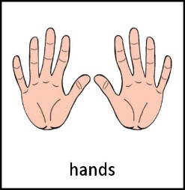](https://www.google.hr/url?sa=i&url=http://www.mypecs.com/pecs_382/hands.aspx&psig=AOvVaw3HZsPQ5D3Xfe4aPSfX_my6&ust=1588707959622000&source=images&cd=vfe&ved=0CAIQjRxqFwoTCID-vcf8mukCFQAAAAAdAAAAABAD) moje .