Koju pjesmicu si sada pročitao?

Majčine ruke

Uskrsni zec

Crvenkapica

Što dijete vidi iz svog kreveta? Odaberi jednu sličicu.

[](https://www.google.hr/url?sa=i&url=https://www.123rf.com/photo_33741819_stock-vector-comic-cloud-vector.html&psig=AOvVaw0ysyfJcsd1Ya8RAG2KkwmI&ust=1588710122747000&source=images&cd=vfe&ved=0CAIQjRxqFwoTCLCM5siEm-kCFQAAAAAdAAAAABAJ)

[](https://www.google.hr/url?sa=i&url=http://clipart-library.com/cartoon-moon-cliparts.html&psig=AOvVaw2cIb0vBcxYXbxrOk0Zsh0o&ust=1588709969152000&source=images&cd=vfe&ved=0CAIQjRxqFwoTCLjo5f2Dm-kCFQAAAAAdAAAAABAM)

[](https://www.google.hr/url?sa=i&url=https://www.shutterstock.com/search/sun+cartoon&psig=AOvVaw2NRhmMvl3j96crNyiCtguX&ust=1588710061422000&source=images&cd=vfe&ved=0CAIQjRxqFwoTCODEq6qEm-kCFQAAAAAdAAAAABAD)

Što mjesecu viri iz torbe? Odaberi jednu sličicu.

[](https://www.google.hr/url?sa=i&url=https://depositphotos.com/195858922/stock-illustration-cartoon-open-book-frog-prince.html&psig=AOvVaw3eofv79FpK5yvN1cry3KGb&ust=1588710374615000&source=images&cd=vfe&ved=0CAIQjRxqFwoTCMil7b-Fm-kCFQAAAAAdAAAAABAO)

[](https://www.google.hr/url?sa=i&url=https://www.vectorstock.com/royalty-free-vector/apple-fruit-cartoon-isolated-vector-23940209&psig=AOvVaw3zlgZVrGnyuDHRxnXzMUMM&ust=1588710329425000&source=images&cd=vfe&ved=0CAIQjRxqFwoTCKDe26mFm-kCFQAAAAAdAAAAABAJ)

[](https://www.google.hr/url?sa=i&url=https://en.wikipedia.org/wiki/File:Orange_cat_cartoon.png&psig=AOvVaw30xnYMgCLD2VFTmW3J8w2m&ust=1588710259643000&source=images&cd=vfe&ved=0CAIQjRxqFwoTCNDwiYmFm-kCFQAAAAAdAAAAABAO)

Tko uvečer , prije spavanja pokriva dijete?

[](https://www.google.hr/url?sa=i&url=https://en.wikipedia.org/wiki/File:Orange_cat_cartoon.png&psig=AOvVaw30xnYMgCLD2VFTmW3J8w2m&ust=1588710259643000&source=images&cd=vfe&ved=0CAIQjRxqFwoTCNDwiYmFm-kCFQAAAAAdAAAAABAO)

[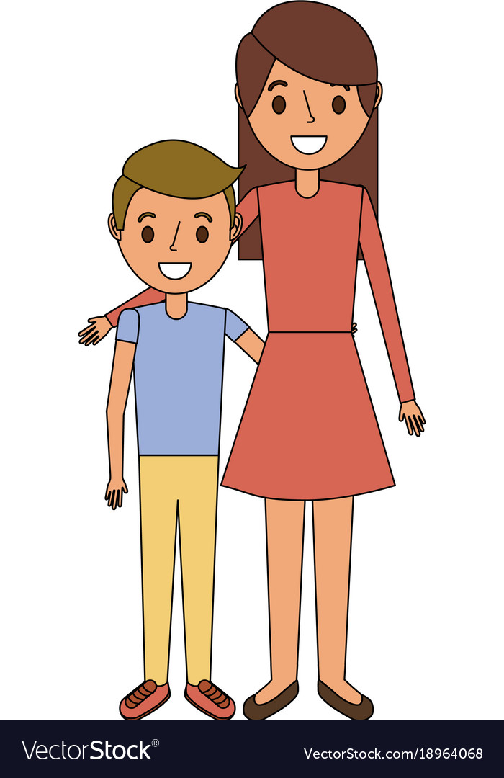](https://www.google.hr/url?sa=i&url=https://www.vectorstock.com/royalty-free-vector/mom-embracing-her-boy-son-happy-vector-18964068&psig=AOvVaw0opPTW8dTImtxmuMi4A_a6&ust=1588710711021000&source=images&cd=vfe&ved=0CAIQjRxqFwoTCJCbo--Gm-kCFQAAAAAdAAAAABAU)

[](https://www.google.hr/url?sa=i&url=https://www.hiclipart.com/free-transparent-background-png-clipart-dtogq&psig=AOvVaw2rYWpkjlffLa83Z1K7JT13&ust=1588710593081000&source=images&cd=vfe&ved=0CAIQjRxqFwoTCOif4qiGm-kCFQAAAAAdAAAAABAO)

[](https://www.google.hr/url?sa=i&url=https://www.pngguru.com/free-transparent-background-png-clipart-wktzs&psig=AOvVaw2rYWpkjlffLa83Z1K7JT13&ust=1588710593081000&source=images&cd=vfe&ved=0CAIQjRxqFwoTCOif4qiGm-kCFQAAAAAdAAAAABAJ)