Logopedske vježbe 13.05.2020

G.O.

Zadatak: Pogledaj slike. Što je na slici? Prepiši riječi koje su točne.

četka čekta četka

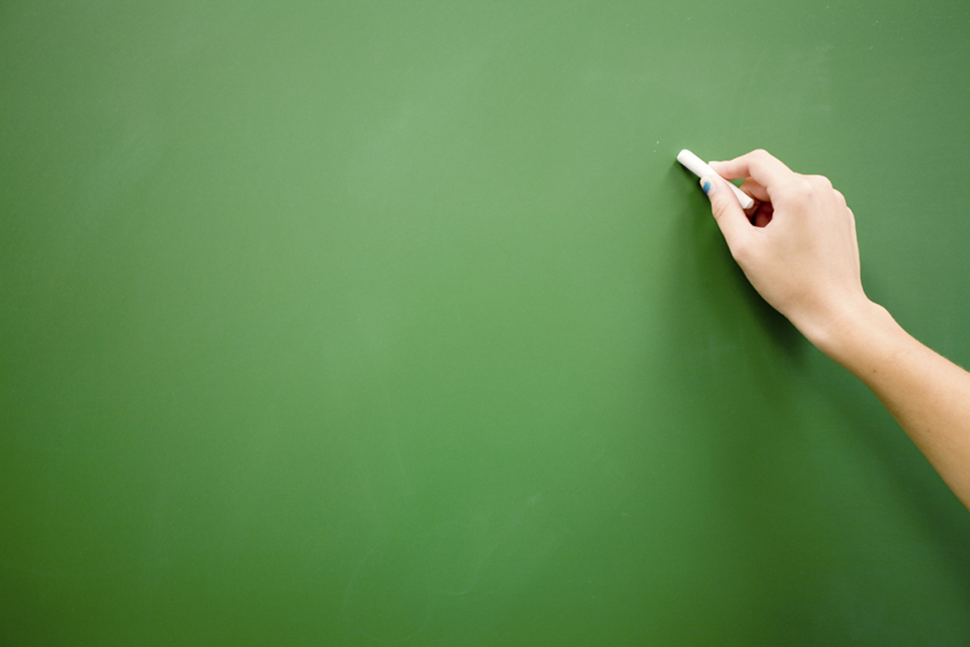

čitka kečap

___________________________________________________________________________

 keski keseki

keksi kokos

__________________________________________________________________________________

kreba krepa

kereda kreda