[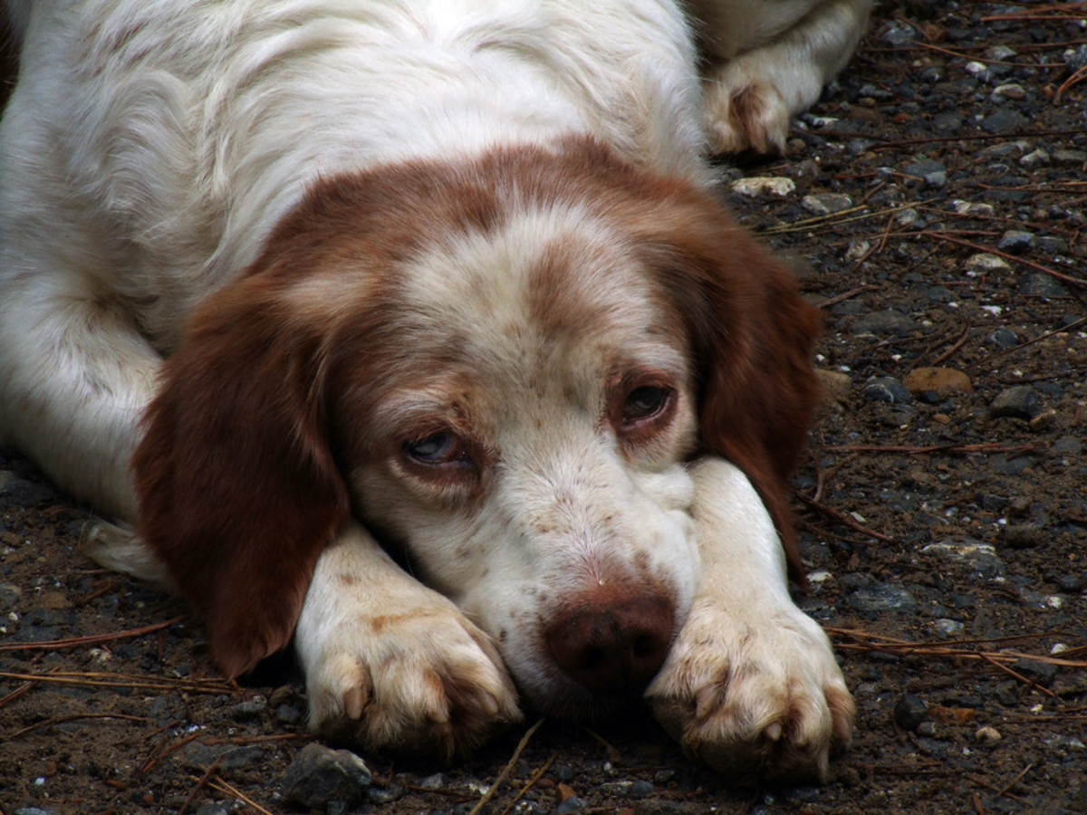](https://www.google.hr/url?sa=i&url=https://www.backpacker.com/skills/how-to-save-your-dogs-life&psig=AOvVaw1BjJ8KYbuUv-HVPWvPfWUp&ust=1590098999698000&source=images&cd=vfe&ved=0CAIQjRxqFwoTCNDr2cu6w-kCFQAAAAAdAAAAABAK)

[](https://www.google.hr/url?sa=i&url=https://imperfectlynatural.com/big-hair-moment-at-theperfects-one-of-my-favorite-from-yesterday/&psig=AOvVaw12FZCZ2N8trHLBnP13ECsY&ust=1590098805484000&source=images&cd=vfe&ved=0CAIQjRxqFwoTCJDD1Om5w-kCFQAAAAAdAAAAABAZ)

SRETAN PAS TUŽAN PAS