**KUĆNI LJUBIMCI SU BIĆA KOJA IMAJU EMOCIJE KAO I MI.**

**OSJEĆAJU TUGU I SREĆU. ONI NISU IGRAČKE.**

**PRIMJERENA PONAŠANJA PREMA KUĆNIM LJUBIMCIMA**[](https://www.google.hr/url?sa=i&url=http://engleskifudbal.com/vesti/fantazi/fantazi-menadzer-after-parti-4/&psig=AOvVaw34f3fIBdcEKT1wrlDW56i3&ust=1590097354827000&source=images&cd=vfe&ved=0CAIQjRxqFwoTCNjK9bK0w-kCFQAAAAAdAAAAABAY)

DATI HRANU

DATI VODU

[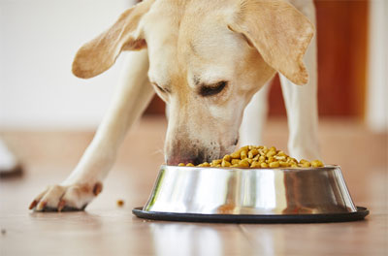](https://www.google.hr/url?sa=i&url=https://vetwork.co/galaxy/ar/%D9%81%D9%88%D8%A7%D8%A6%D8%AF-%D9%88%D8%A7%D8%B6%D8%B1%D8%A7%D8%B1-%D8%A7%D9%84%D8%AF%D8%B1%D8%A7%D9%8A-%D9%81%D9%88%D8%AF-%D9%84%D9%84%D9%83%D9%84%D8%A7%D8%A8/&psig=AOvVaw2IBmy-fTZXOgqRTZUSsZ9u&ust=1590096240359000&source=images&cd=vfe&ved=0CAIQjRxqFwoTCKDE6qSww-kCFQAAAAAdAAAAABAJ)

[](https://www.google.hr/url?sa=i&url=https://mascotaabordo.com/consumo-de-agua-perros/&psig=AOvVaw3s8SuCOMIutWKdMtzf65ve&ust=1590095962979000&source=images&cd=vfe&ved=0CAIQjRxqFwoTCIjA_aKvw-kCFQAAAAAdAAAAABAL)

POGLADITI GA

POČEŠLJATI GA

[](https://www.google.hr/url?sa=i&url=https://www.tportal.hr/lifestyle/clanak/sto-nije-lose-znati-o-mazenju-pasa-20170413/print&psig=AOvVaw2Ix7vTJEMc4ZHmEWvbdPvj&ust=1590096476201000&source=images&cd=vfe&ved=0CAIQjRxqFwoTCOjUxZuxw-kCFQAAAAAdAAAAABAO)

[](https://www.google.hr/url?sa=i&url=https://paszavas.com/kako-i-sa-kojom-cetkom-cesljati-psa/&psig=AOvVaw3mCcooa4H_d06RWyt8SJ9w&ust=1590096392290000&source=images&cd=vfe&ved=0CAIQjRxqFwoTCOiWzOiww-kCFQAAAAAdAAAAABAD)

[](https://www.google.hr/url?sa=i&url=https://www.13newsnow.com/article/life/pets/vetanxiety/291-8b61dc63-6b21-493a-aab7-5021b3c4b14b&psig=AOvVaw0llrYO7swlZptwXNVBRO0o&ust=1590097477606000&source=images&cd=vfe&ved=0CAIQjRxqFwoTCMDqnva0w-kCFQAAAAAdAAAAABAK)

IGRATI SE

[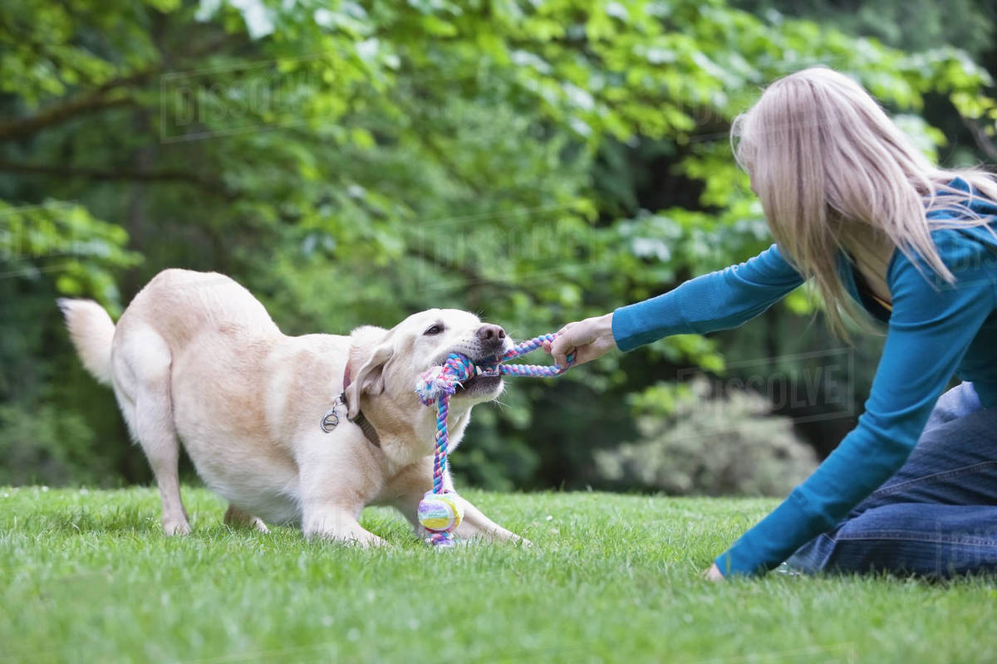](https://www.google.hr/url?sa=i&url=https://dissolve.com/stock-photo/Girl-playing-tug-war-royalty-free-image/101-D1028-86-396&psig=AOvVaw28e-KzdQenaaScIwTYmg8y&ust=1590096937826000&source=images&cd=vfe&ved=0CAIQjRxqFwoTCPjkpe-yw-kCFQAAAAAdAAAAABAk)

VODITI VETERINARU

NEPRIMJERENA PONAŠANJA PREMA KUĆNIM LJUBIMCIMA[](https://www.google.hr/url?sa=i&url=http://www.otvoreni.hr/muskost-se-ne-nalazi-ispod-papucice-gasa/&psig=AOvVaw34f3fIBdcEKT1wrlDW56i3&ust=1590097354827000&source=images&cd=vfe&ved=0CAIQjRxqFwoTCNjK9bK0w-kCFQAAAAAdAAAAABAJ)

NAPUSTITI GA

VUĆI ZA REP

UDARATI

VEZATI LANCEM

[](https://www.google.hr/url?sa=i&url=http://www.voyageavectonchien.com/en/abandonment/&psig=AOvVaw3OvDtexlcZi_h5fDKOKBdn&ust=1590098169826000&source=images&cd=vfe&ved=0CAIQjRxqFwoTCLik97e3w-kCFQAAAAAdAAAAABAO)

[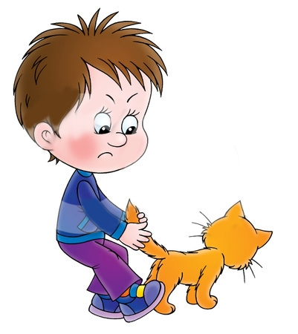](https://www.google.hr/url?sa=i&url=https://webstockreview.net/image/bad-clipart-bad-kid/309833.html&psig=AOvVaw32ajSm_IkctOvvdPqWoYvL&ust=1590098032196000&source=images&cd=vfe&ved=0CAIQjRxqFwoTCJDugfu2w-kCFQAAAAAdAAAAABAO)

[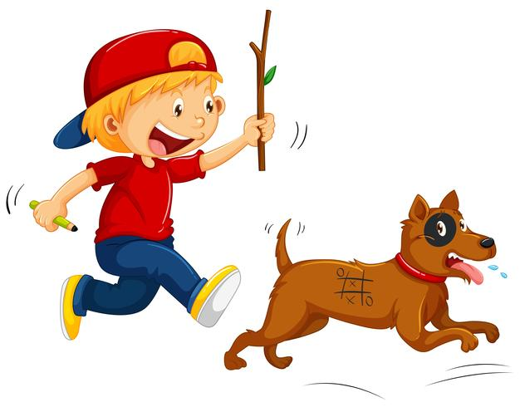](https://www.google.hr/url?sa=i&url=https://www.vecteezy.com/vector-art/377134-boy-teasing-little-dog&psig=AOvVaw1qEy7bM6yTAzqQvkdNUDsr&ust=1590097835057000&source=images&cd=vfe&ved=0CAIQjRxqFwoTCMirxZu2w-kCFQAAAAAdAAAAABAJ)

[](https://www.google.hr/url?sa=i&url=https://petface.net/na-lancu/&psig=AOvVaw1smRi7C1_Hku4UWvZs5R_Y&ust=1590097627735000&source=images&cd=vfe&ved=0CAIQjRxqFwoTCIjGjLW1w-kCFQAAAAAdAAAAABAP)