Pričanje priče : PILIĆI I SJEMENKA SUNCOKRETA

Pogledaj svaku sličicu i reci po jednu rečenicu.

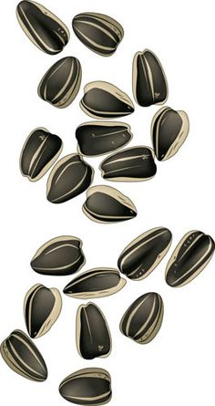

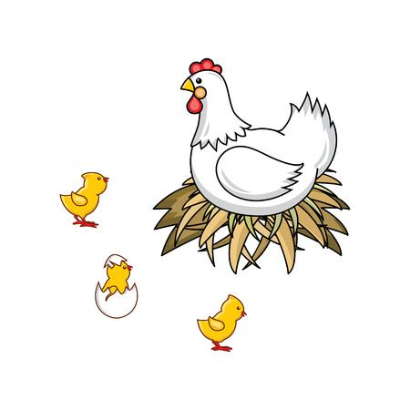

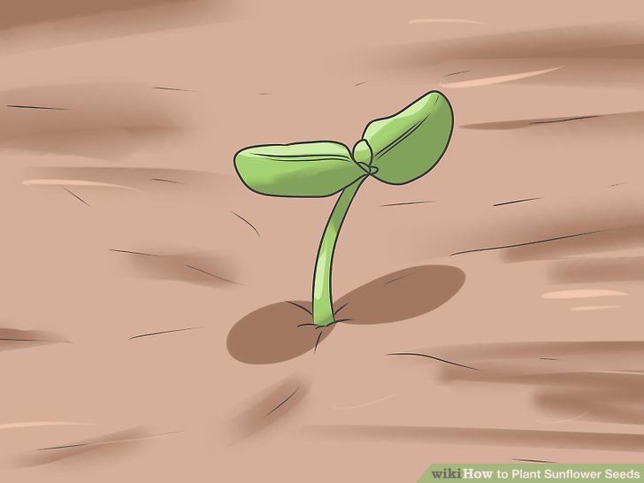

[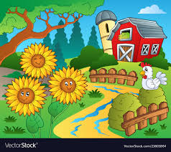](https://www.google.hr/url?sa=i&url=https://www.vectorstock.com/royalty-free-vector/farm-theme-with-sunflowers-vector-21601864&psig=AOvVaw2Pu3O-wtFOVd8KtVY4Vy7J&ust=1590178399769000&source=images&cd=vfe&ved=0CAIQjRxqFwoTCODrtanixekCFQAAAAAdAAAAABAD)

[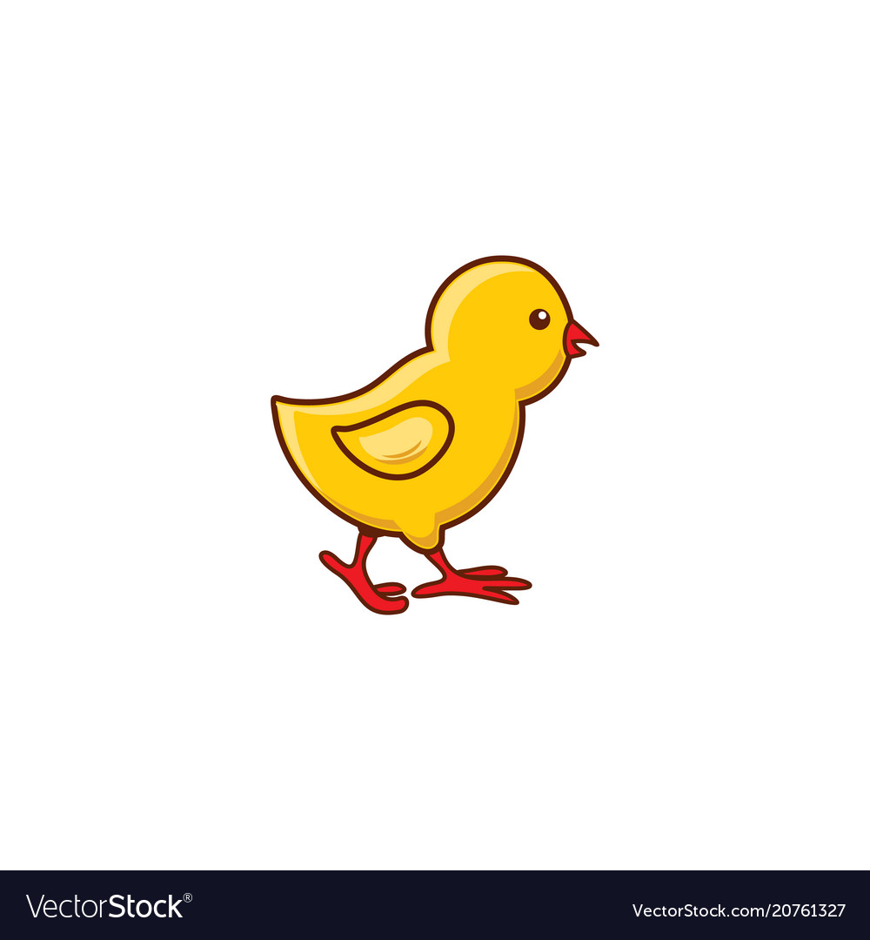](https://www.google.hr/url?sa=i&url=https://www.vectorstock.com/royalty-free-vectors/chick-side-chicken-vectors&psig=AOvVaw05gfuJZ3dvp4d89tvulVWs&ust=1590177865464000&source=images&cd=vfe&ved=0CAIQjRxqFwoTCLCg97HgxekCFQAAAAAdAAAAABAS) [](https://www.google.hr/url?sa=i&url=https://www.vectorstock.com/royalty-free-vectors/chick-side-chicken-vectors&psig=AOvVaw05gfuJZ3dvp4d89tvulVWs&ust=1590177865464000&source=images&cd=vfe&ved=0CAIQjRxqFwoTCLCg97HgxekCFQAAAAAdAAAAABAS)[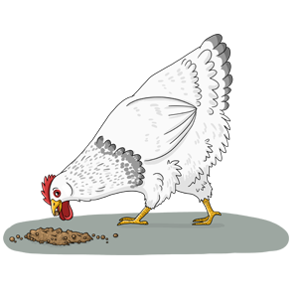](https://www.google.hr/url?sa=i&url=https://nichepets.com/birds/chickens/what-do-chickens-eat/&psig=AOvVaw2vO7mXgM82Fnlg5qUuhl3y&ust=1590177781579000&source=images&cd=vfe&ved=0CAIQjRxqFwoTCJDtv47gxekCFQAAAAAdAAAAABAP)

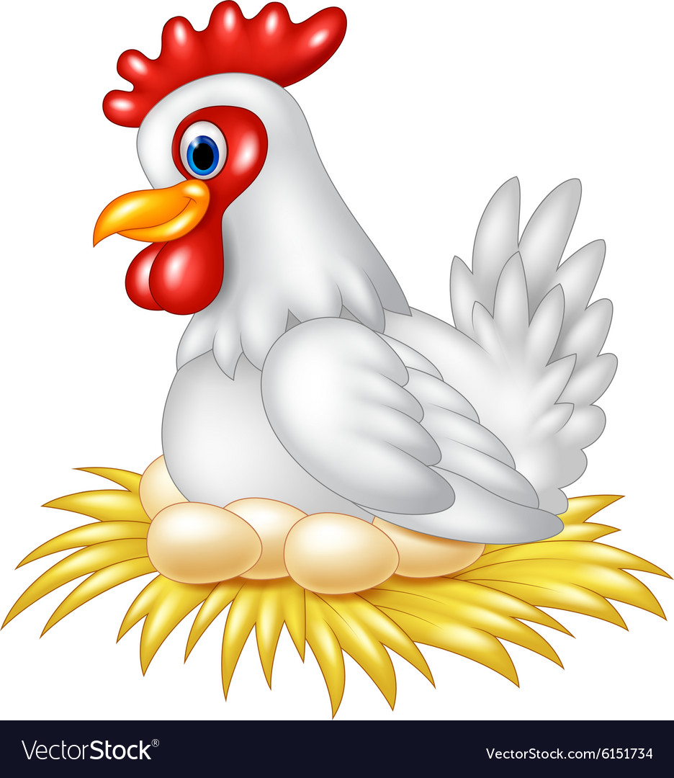

[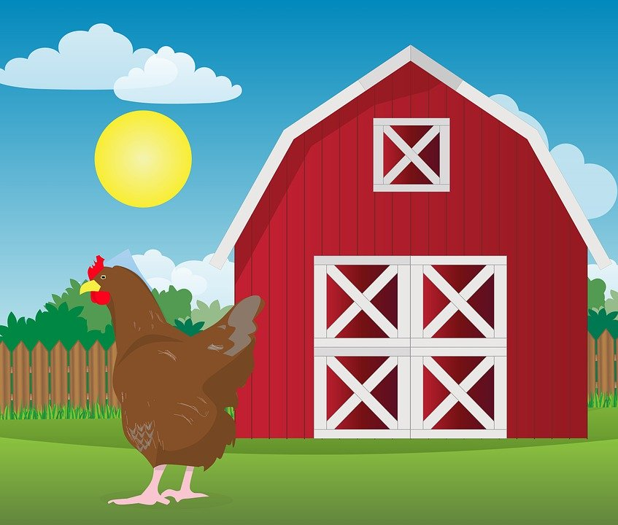](https://www.google.hr/url?sa=i&url=https://pixabay.com/illustrations/chicken-farm-hen-range-animal-5024775/&psig=AOvVaw2zeG97em-za8jFzfO5nn3m&ust=1590177484534000&source=images&cd=vfe&ved=0CAIQjRxqFwoTCODe-YHfxekCFQAAAAAdAAAAABAD)