ŠTO MOGU [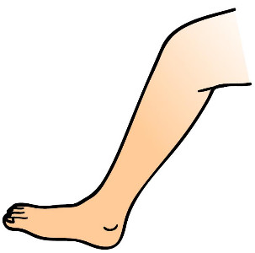](https://www.google.hr/url?sa=i&url=https://www.kissclipart.com/vocabulary-clipart-foot-em7gku/&psig=AOvVaw1YMuZeRtzzjDUET9aAA00L&ust=1590608435901000&source=images&cd=vfe&ved=0CAIQjRxqFwoTCNCnwrGk0ukCFQAAAAAdAAAAABAK)

[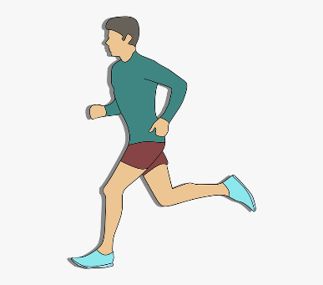](https://www.google.hr/url?sa=i&url=https://www.pngitem.com/middle/xxTJmo_transparent-running-legs-png-cartoon-running-png-png/&psig=AOvVaw1YMuZeRtzzjDUET9aAA00L&ust=1590608435901000&source=images&cd=vfe&ved=0CAIQjRxqFwoTCNCnwrGk0ukCFQAAAAAdAAAAABAX) [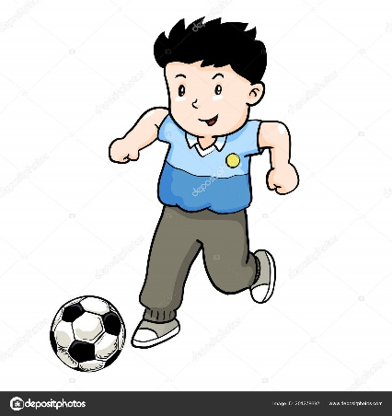](https://www.google.hr/url?sa=i&url=https://depositphotos.com/201278692/stock-illustration-boy-playing-football-cartoon-kid.html&psig=AOvVaw1hT_YZWxQrykftOFWWynAS&ust=1590608636564000&source=images&cd=vfe&ved=0CAIQjRxqFwoTCLCM9I-l0ukCFQAAAAAdAAAAABAf)

[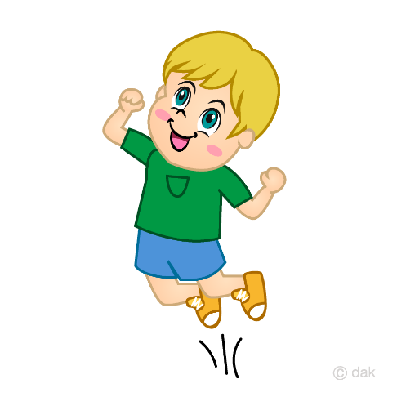](https://www.google.hr/url?sa=i&url=https://illustoon.com/?id=2064&psig=AOvVaw0lr6foRa6LKQDM7D5tRt0I&ust=1590608737215000&source=images&cd=vfe&ved=0CAIQjRxqFwoTCJCchL2l0ukCFQAAAAAdAAAAABAD)[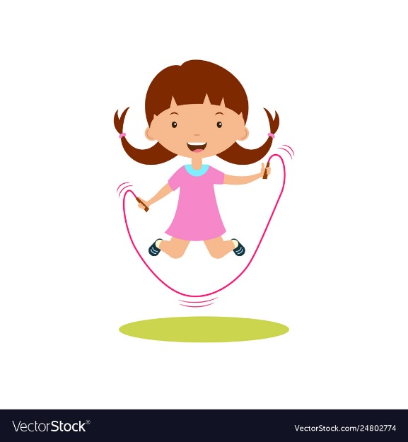](https://www.google.hr/url?sa=i&url=https://www.vectorstock.com/royalty-free-vector/cute-cartoon-girl-jumping-rope-vector-24802774&psig=AOvVaw0lr6foRa6LKQDM7D5tRt0I&ust=1590608737215000&source=images&cd=vfe&ved=0CAIQjRxqFwoTCJCchL2l0ukCFQAAAAAdAAAAABAX)

[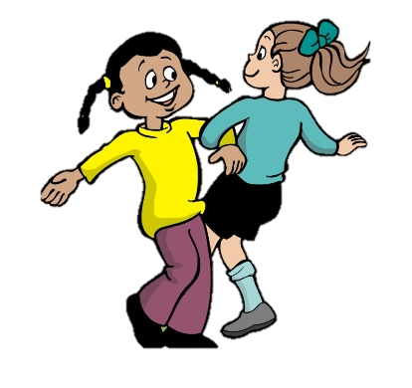](https://www.google.hr/url?sa=i&url=https://www.pinclipart.com/maxpin/hbihTJ/&psig=AOvVaw3YEdOCFa3v6F0LHOCR-8vS&ust=1590608848260000&source=images&cd=vfe&ved=0CAIQjRxqFwoTCJjA1_Wl0ukCFQAAAAAdAAAAABAd) [](https://www.google.hr/url?sa=i&url=https://clipartstation.com/steps-clipart-1/&psig=AOvVaw0YKQw3s8MZVwOpHyT4VeZ-&ust=1590608977835000&source=images&cd=vfe&ved=0CAIQjRxqFwoTCNjZ07Km0ukCFQAAAAAdAAAAABAU)