Kamo idemo kada se moramo šišati?

[](https://www.google.hr/url?sa=i&url=https://www.oglasnik.hr/ponuda-poslova/kuhar-i-pomocni-kuhar-m-z-oglas-3913033&psig=AOvVaw1m-FfB4o4g0NpvgfAjXPP8&ust=1590772970297000&source=images&cd=vfe&ved=0CAIQjRxqFwoTCIict6WJ1-kCFQAAAAAdAAAAABAD)

[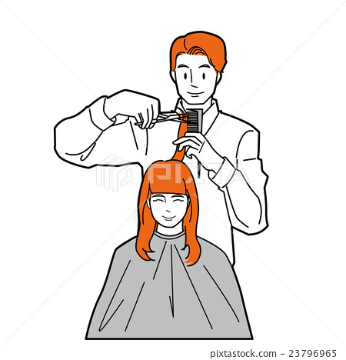](https://www.google.hr/url?sa=i&url=https://www.pixtastock.com/illustration/23796965&psig=AOvVaw0uqW8Lvp8EN_a0eHinTcTK&ust=1590772740804000&source=images&cd=vfe&ved=0CAIQjRxqFwoTCMCN6reI1-kCFQAAAAAdAAAAABA7)

[](https://www.google.hr/url?sa=i&url=https://www.facebook.com/aquaticzagreb/&psig=AOvVaw0uqW8Lvp8EN_a0eHinTcTK&ust=1590772740804000&source=images&cd=vfe&ved=0CAIQjRxqFwoTCMCN6reI1-kCFQAAAAAdAAAAABAD)

Koji pribor koristi frizer?

[](https://www.google.hr/url?sa=i&url=https://www.pixtastock.com/illustration/23796965&psig=AOvVaw0uqW8Lvp8EN_a0eHinTcTK&ust=1590772740804000&source=images&cd=vfe&ved=0CAIQjRxqFwoTCMCN6reI1-kCFQAAAAAdAAAAABA7)

[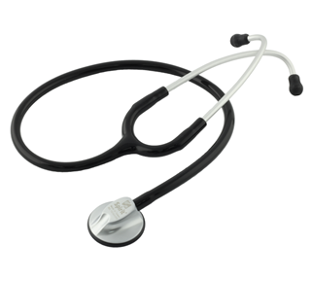](https://www.google.hr/url?sa=i&url=https://www.datastatus.rs/proizvod/61880/spirit-stetoskop-ck-m601p-crni-stetoskop-za-opstu-praksu?katid=12&type=u&psig=AOvVaw0aWZX0snBrvs4gre-9MXhV&ust=1590773408079000&source=images&cd=vfe&ved=0CAIQjRxqFwoTCJDqqPaK1-kCFQAAAAAdAAAAABAN)

[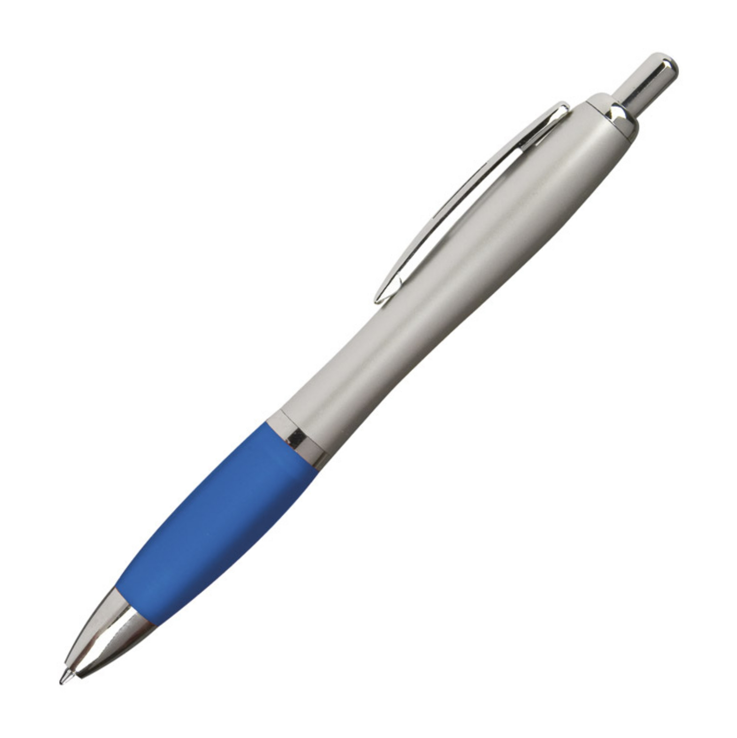](https://www.google.hr/url?sa=i&url=https://pelin1971.hr/katalog/tisak-na-kemijske-olovke/&psig=AOvVaw3Iz2E8-wH7eoqnAlH2nrvm&ust=1590773350824000&source=images&cd=vfe&ved=0CAIQjRxqFwoTCMChldmK1-kCFQAAAAAdAAAAABAJ)

[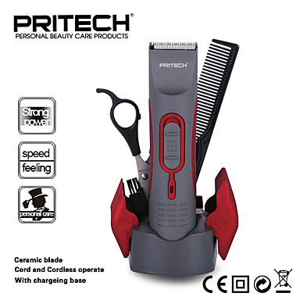](https://www.google.hr/url?sa=i&url=https://www.lightinthebox.com/hr/p/pritech-profesionalni-elektricni-aparat-za-sisanje-kose-trimer-za-muskarce-i-bebe-kose-rezanje-stroj-baber-alat_p3809217.html&psig=AOvVaw1uzczhxG0GSZwml7LRX4ZX&ust=1590773238653000&source=images&cd=vfe&ved=0CAIQjRxqFwoTCLCAoqaK1-kCFQAAAAAdAAAAABAD)

Kada idemo frizeru?

[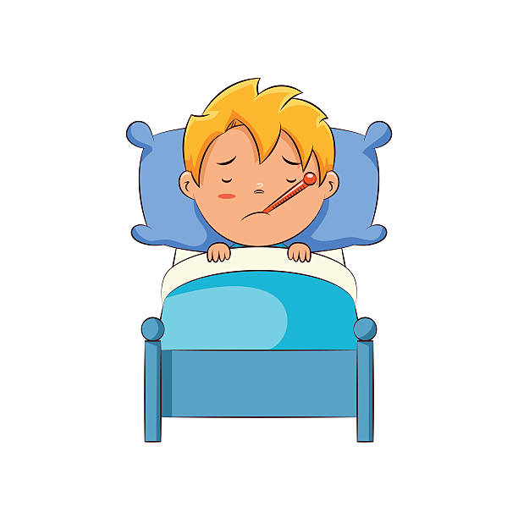](https://www.google.hr/url?sa=i&url=https://clipartstation.com/sick-boy-clipart-2/&psig=AOvVaw1nbU_zGQD9Ezeb1nOfVy0n&ust=1590773827431000&source=images&cd=vfe&ved=0CAIQjRxqFwoTCMDB9r2M1-kCFQAAAAAdAAAAABAx)

[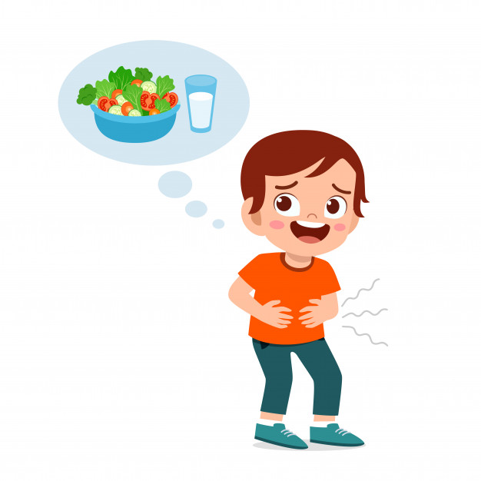](https://www.google.hr/url?sa=i&url=https://www.freepik.com/free-photos-vectors/hungry&psig=AOvVaw0ZRc00X1v7GTXKgVyT0kDC&ust=1590773890706000&source=images&cd=vfe&ved=0CAIQjRxqFwoTCKCWmt2M1-kCFQAAAAAdAAAAABAD)

[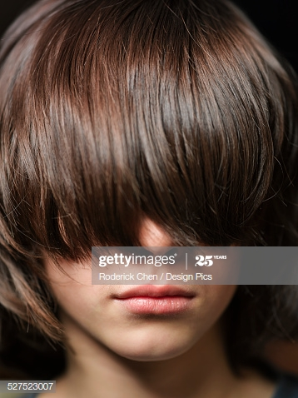](https://www.google.hr/url?sa=i&url=https://www.gettyimages.de/detail/foto/young-boy-with-long-brunette-hair-covering-his-eyes-lizenzfreies-bild/527523007&psig=AOvVaw2KcculQ3zQe0HNQjsNn0Aw&ust=1590773502377000&source=images&cd=vfe&ved=0CAIQjRxqFwoTCLC5hPqL1-kCFQAAAAAdAAAAABAM)