PONEDJELJAK, 1.6.2020.

Razvrstavanje i zbrinjavanje otpada

RAZVRSTAJ OTPAD I SPOJI OTPAD S NJEGOVIM SPREMNIKOM:

[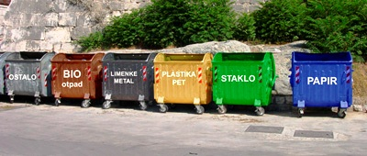](https://www.google.hr/url?sa=i&url=https://www.razredna-nastava.net/stranica.php?id%3D531&psig=AOvVaw3c4DOWV8pPKaLuLQXGM8GO&ust=1590621323539000&source=images&cd=vfe&ved=0CAIQjRxqFwoTCIjV5KzU0ukCFQAAAAAdAAAAABAD)

[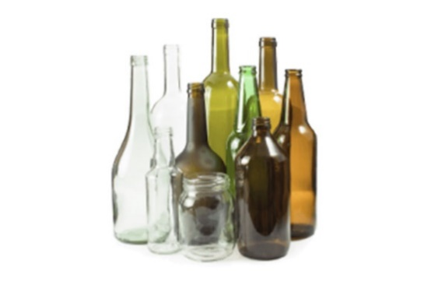](https://www.google.hr/url?sa=i&url=https://rcco.hr/staklo/&psig=AOvVaw024T8BkZb3X7Tmt1ep8ojQ&ust=1590621391588000&source=images&cd=vfe&ved=0CAIQjRxqFwoTCNCs1M_U0ukCFQAAAAAdAAAAABAD)[](https://www.google.hr/url?sa=i&url=https://adriacalix.com/proizvodi/bijeli-newsprint-papir-otporan-masnocu-dispenzeru-350x270mm&psig=AOvVaw1ILyObPx-n5GX5fTZP69sc&ust=1590621428722000&source=images&cd=vfe&ved=0CAIQjRxqFwoTCPCGteHU0ukCFQAAAAAdAAAAABAE)[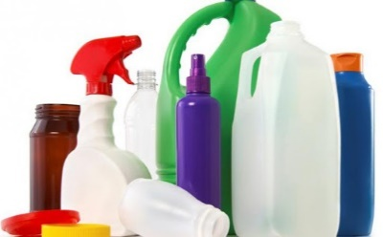](https://www.google.hr/url?sa=i&url=http://suvremena.hr/industrija-plastike-nije-neprijatelj-okolisa/&psig=AOvVaw1zuYSr3Gq1l8lq9mW7E6FQ&ust=1590621471294000&source=images&cd=vfe&ved=0CAIQjRxqFwoTCPCEzfXU0ukCFQAAAAAdAAAAABAD)[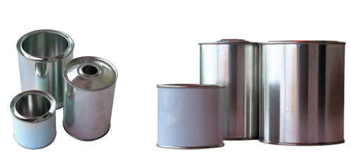](https://www.google.hr/url?sa=i&url=http://www.mgk-pack.com/zavarene-limenke.html&psig=AOvVaw2Zk4nkpoUVh5ZI-EU36XR7&ust=1590621498598000&source=images&cd=vfe&ved=0CAIQjRxqFwoTCKjc3oTV0ukCFQAAAAAdAAAAABAD)

[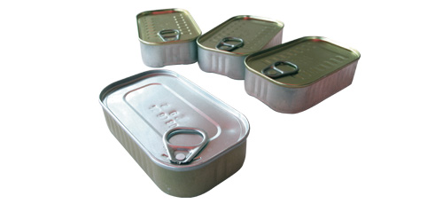](https://www.google.hr/url?sa=i&url=http://www.mgk-pack.com/vucene-limenke-club.html&psig=AOvVaw2Zk4nkpoUVh5ZI-EU36XR7&ust=1590621498598000&source=images&cd=vfe&ved=0CAIQjRxqFwoTCKjc3oTV0ukCFQAAAAAdAAAAABAJ) [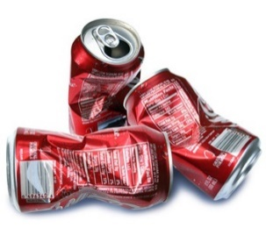](https://www.google.hr/url?sa=i&url=https://www.zcgo.hr/otpad-u-zagrebu-pregled/metalna-ambalaza-i-limenke&psig=AOvVaw2Zk4nkpoUVh5ZI-EU36XR7&ust=1590621498598000&source=images&cd=vfe&ved=0CAIQjRxqFwoTCKjc3oTV0ukCFQAAAAAdAAAAABAP)[](https://www.google.hr/url?sa=i&url=https://www.zivimo-ekologicno.eu/bio-otpad/&psig=AOvVaw3YCZviSua_Q1NGm8dIT_HS&ust=1590621598717000&source=images&cd=vfe&ved=0CAIQjRxqFwoTCMD98LHV0ukCFQAAAAAdAAAAABAD)