**[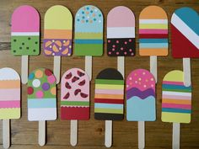](https://www.pinterest.com/pin/581808845582177303/)**

[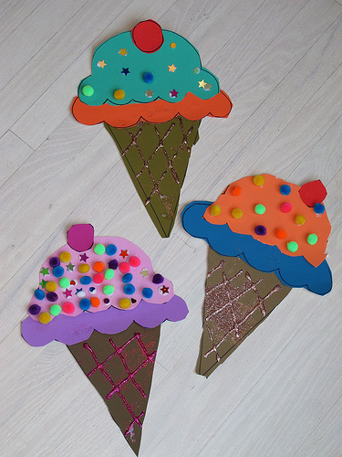](https://www.google.hr/url?sa=i&url=https://funfamilycrafts.com/paper-ice-cream-cones-2/&psig=AOvVaw1RRP4nylvRz1UhhBjooqCB&ust=1591379777770000&source=images&cd=vfe&ved=0CAIQjRxqFwoTCODEyPLd6OkCFQAAAAAdAAAAABAS)