Spustila se [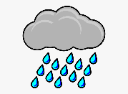](https://www.google.hr/url?sa=i&url=https://www.netclipart.com/isee/TwRRh_rain-clip-art-free-free-clipart-images-rainy/&psig=AOvVaw3mrniLqepA5RnPM6zCLtVq&ust=1591378037445000&source=images&cd=vfe&ved=0CAIQjRxqFwoTCJCR7qjX6OkCFQAAAAAdAAAAABAP)

Spustila se [](https://www.google.hr/url?sa=i&url=https://www.netclipart.com/isee/TwRRh_rain-clip-art-free-free-clipart-images-rainy/&psig=AOvVaw3mrniLqepA5RnPM6zCLtVq&ust=1591378037445000&source=images&cd=vfe&ved=0CAIQjRxqFwoTCJCR7qjX6OkCFQAAAAAdAAAAABAP)

naljutila [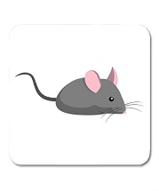](https://www.google.hr/url?sa=i&url=https://www.amazon.com/Semtomn-Rectangle-Notebook-Computer-Accessories/dp/B07MS8T2YF&psig=AOvVaw1FZpurNFHSBSdXGetcyX8S&ust=1591378171789000&source=images&cd=vfe&ved=0CAIQjRxqFwoTCPjP4-vX6OkCFQAAAAAdAAAAABAJ).

I smočila [](https://www.google.hr/url?sa=i&url=https://www.vreme.com/cms/view.php?id=464249&print=yes&psig=AOvVaw38BAKWXIpz9WtRmWzqXmQy&ust=1591378278059000&source=images&cd=vfe&ved=0CAIQjRxqFwoTCMiL75rY6OkCFQAAAAAdAAAAABAJ)

dok je pasla [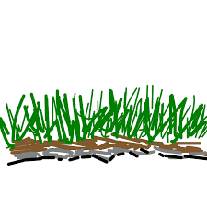](https://www.google.hr/url?sa=i&url=https://letsdraw.it/de/h/wie-zeichnet-man-Gras/m1ja4i&psig=AOvVaw38gZ4rUuaQg_f3knUD_kED&ust=1591378323107000&source=images&cd=vfe&ved=0CAIQjRxqFwoTCJDm77fY6OkCFQAAAAAdAAAAABAL).

Jednom [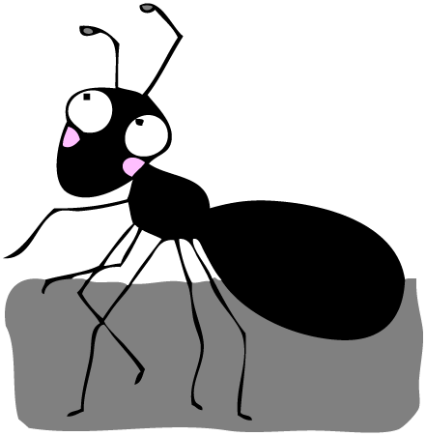](https://www.google.hr/url?sa=i&url=http://www.sveosvemu.com/kako-otjerati-mrave&psig=AOvVaw2GwWNCWvyXzUObS0UGqRyW&ust=1591378480988000&source=images&cd=vfe&ved=0CAIQjRxqFwoTCKDLwPzY6OkCFQAAAAAdAAAAABAD)

pala je na [](https://www.google.hr/url?sa=i&url=http://www.sveosvemu.com/kako-otjerati-mrave&psig=AOvVaw2GwWNCWvyXzUObS0UGqRyW&ust=1591378480988000&source=images&cd=vfe&ved=0CAIQjRxqFwoTCKDLwPzY6OkCFQAAAAAdAAAAABAD)

[](https://www.google.hr/url?sa=i&url=https://webcomicms.net/clipart-9254833-butterfly-cartoon-images&psig=AOvVaw3HNBSueQ6I1qoQhBo-Y3--&ust=1591378636035000&source=images&cd=vfe&ved=0CAIQjRxqFwoTCJDOr8zZ6OkCFQAAAAAdAAAAABAJ)je ljut

mokar mu [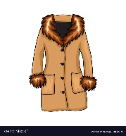](https://www.google.hr/url?sa=i&url=https://www.vectorstock.com/royalty-free-vector/cartoon-fur-winter-coat-isolated-on-white-vector-21864918&psig=AOvVaw1MiMmjeqntW6bXWL8CFhMf&ust=1591378731339000&source=images&cd=vfe&ved=0CAIQjRxqFwoTCLCW1PPZ6OkCFQAAAAAdAAAAABAl).

Samo [](https://www.google.hr/url?sa=i&url=https://www.123rf.com/photo_51556728_stock-vector-three-cartoon-flowers-blue-pink-purple-isolated-on-white.html&psig=AOvVaw39J8I0NjMj2vDySMZS5fBo&ust=1591378916810000&source=images&cd=vfe&ved=0CAIQjRxqFwoTCIjM8Mva6OkCFQAAAAAdAAAAABAJ) nije

Na [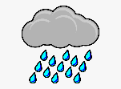](https://www.google.hr/url?sa=i&url=https://www.netclipart.com/isee/TwRRh_rain-clip-art-free-free-clipart-images-rainy/&psig=AOvVaw3mrniLqepA5RnPM6zCLtVq&ust=1591378037445000&source=images&cd=vfe&ved=0CAIQjRxqFwoTCJCR7qjX6OkCFQAAAAAdAAAAABAP) se [](https://www.google.hr/url?sa=i&url=https://dlpng.com/png/6980438&psig=AOvVaw1if4j3H4f0D5EAx9fBmndR&ust=1591379029544000&source=images&cd=vfe&ved=0CAIQjRxqFwoTCKjml4Xb6OkCFQAAAAAdAAAAABAT).

Miroslav Kovačević