ZADATAK: PREBROJI KOLIKO ČEGA IMA!

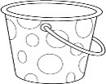

|  |  |  |  |  |
| --- | --- | --- | --- | --- |
| 5 | 7 | 10 | 3 | 4 |

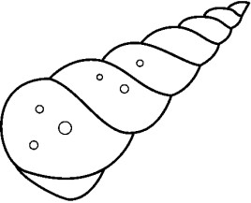

|  |  |  |  |  |
| --- | --- | --- | --- | --- |
| 11 | 2 | 6 | 9 | 1 |

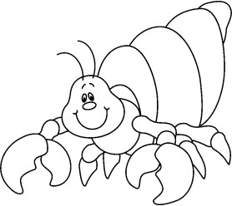 

|  |  |  |  |  |
| --- | --- | --- | --- | --- |
| 8 | 7 | 3 | 12 | 5 |

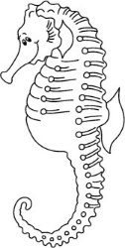       

|  |  |  |  |  |
| --- | --- | --- | --- | --- |
| 1 | 12 | 4 | 9 | 8 |

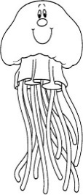

|  |  |  |  |  |
| --- | --- | --- | --- | --- |
| 5 | 10 | 6 | 12 | 11 |

ZADATAK: PREBROJI I ZAOKRUŽI KOLIKO ČEGA IMA!



|  |  |  |  |  |
| --- | --- | --- | --- | --- |
| 7 | 12 | 6 | 2 | 1 |

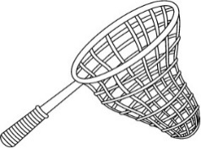

|  |  |  |  |  |
| --- | --- | --- | --- | --- |
| 5 | 8 | 10 | 4 | 9 |

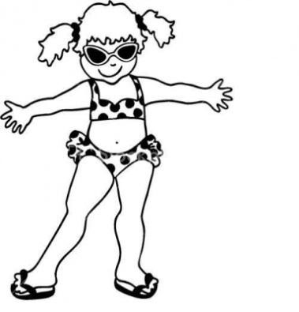

|  |  |  |  |  |
| --- | --- | --- | --- | --- |
| 11 | 7 | 12 | 3 | 2 |