**PRIBOR ZA**

**JELO**

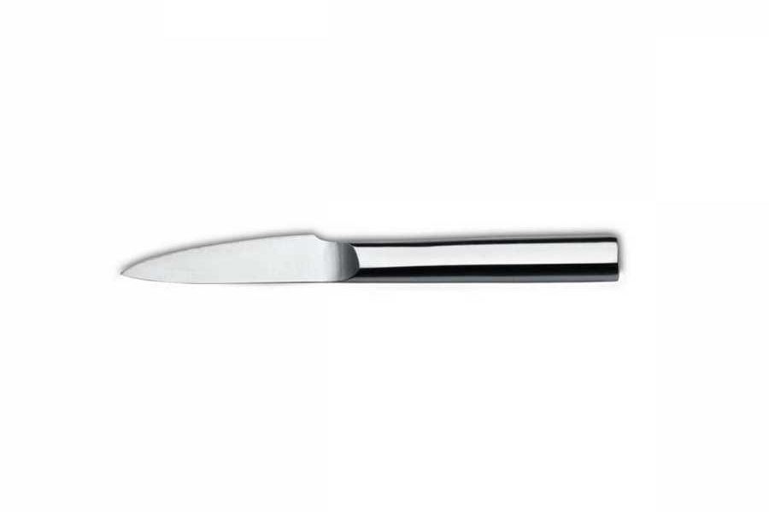 **NOŽ**

**[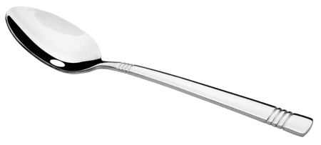](https://www.google.hr/url?sa=i&url=https%3A%2F%2Fwww.mall.hr%2Fpribor-za-jelo2%2Ffackelmann-victoria-zlica%3Ftab%3Ddiscussion&psig=AOvVaw02htfwnKkq3SAXTL2UdfSe&ust=1601020961246000&source=images&cd=vfe&ved=0CAIQjRxqFwoTCOCE2oOqgewCFQAAAAAdAAAAABAD)**

**ŽLICA**

**[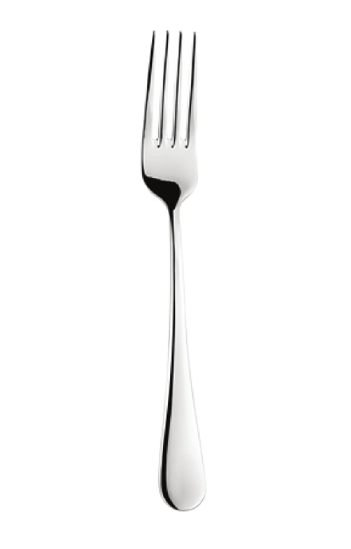](https://www.google.hr/url?sa=i&url=https%3A%2F%2Fwww.abckuchyne.cz%2FArcade-vidlicka-jidelni-d42.htm&psig=AOvVaw1yT7hFtSvDAPcB5kNOhl0O&ust=1601021334910000&source=images&cd=vfe&ved=0CAIQjRxqFwoTCLjnx7mrgewCFQAAAAAdAAAAABAJ)**

**VILICA**