[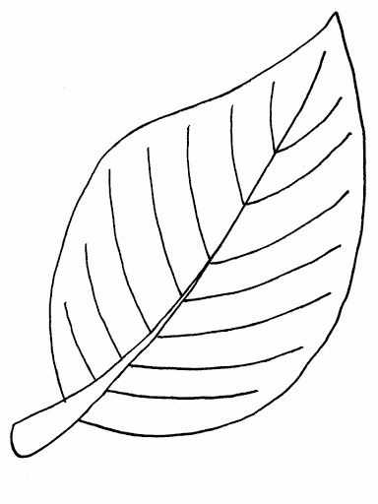](https://www.google.hr/url?sa=i&url=http%3A%2F%2Fwww.bojanke.net%2Fzivotinje%2Fbojanke_lisce%2Findex.html&psig=AOvVaw3vRtFXpN4-JXV-69oSeJ-O&ust=1602526063157000&source=images&cd=vfe&ved=0CAIQjRxqFwoTCIiZiviQrewCFQAAAAAdAAAAABAI)