ZADATAK: VAŠ JE ZADATAK DA UZMETE KRPU I SREDSTVO ZA BRISANJE PRAŠINE I OBRIŠETE POLICE ORMARA, STOL I PROZORSKU DASKU U VAŠOJ SOBI!

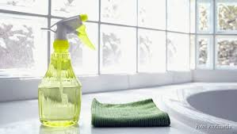

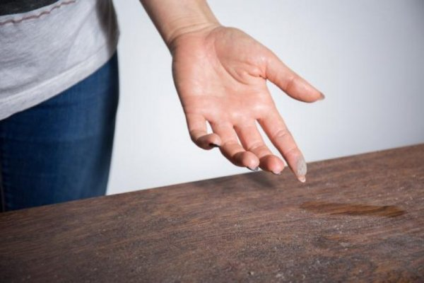
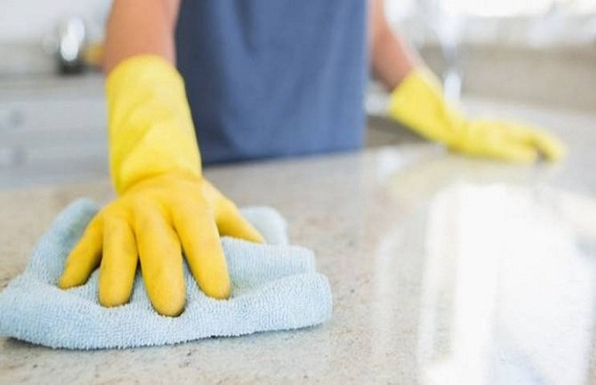
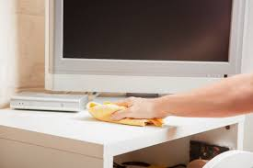
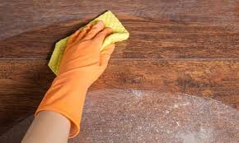

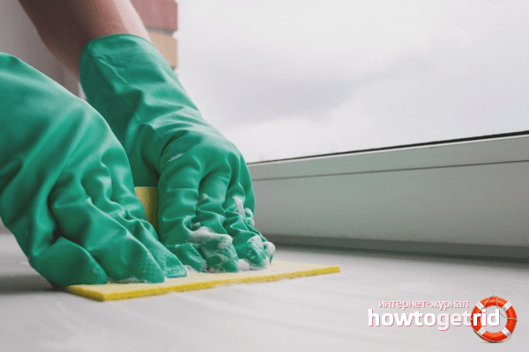

KAD STE OBRISALI PRAŠINU, OTVORITE PROZOR DA UĐE SVJEŽI ZRAK!

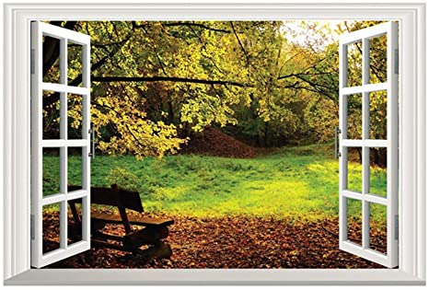

VAŠA JE SOBA ČISTA I UREDNA!
ZAVRŠILI STE SVOJ ZADATAK!
BRAVO!

* Slike su uzete sa internetskih stranica:
https://static.mondo.ba/Picture/273892/jpeg/c-is-c-enje-stefan-stojanovic-3.jpg
https://lh3.googleusercontent.com/proxy/vVoo4X-9_m0X7ROdycUTMQBgpeNtNyyHtcWdNWFJ9-Cf1gYRcmBjvB9KnoAlImqQYm_IZGZCN_2_uqc--GNstsHjtABHiTx4HOT1-wrIQSIHuE1MAI9l
https://lifepressmagazin.com/wp-content/uploads/2014/03/brisanje-prasine-TV.jpg
https://m.novi.ba/storage/2018/04/23/thumbs/5addf95b-044c-432e-ac12-13240a0a0a67-prasina-347gu5yo1i22m28k3k188w-previewOrg.jpg
https://thumbs.dreamstime.com/z/open-window-fresh-air-countryside-scenery-views-red-curtains-opened-show-modern-house-rural-location-onto-stunning-111905718.jpg
https://i1.wp.com/howtogetrid.ru/assets/uploads/2017/01/udalenie-pjaten-i-rzhavchiny-s-podokonnika.png
https://static.mondo.ba/Picture/273892/jpeg/c-is-c-enje-stefan-stojanovic-3.jpg

