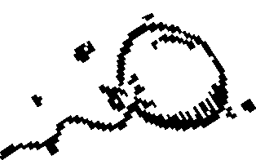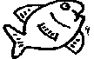Riješi križaljke! Što piše u obojanim poljima?

1

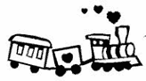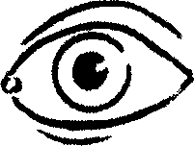

|  |  |  |  |  |  |  |
| --- | --- | --- | --- | --- | --- | --- |
|  |  |  |  |  |  |  |
| 2  3  4  5 |  |  |  |  |  | |
|  |  |  |  | | |
|  |  |  |  |  |  |
|  |  |  |  |  |  |

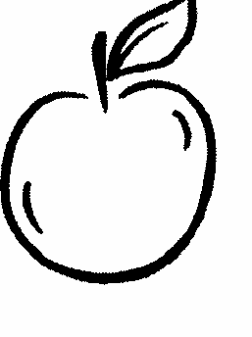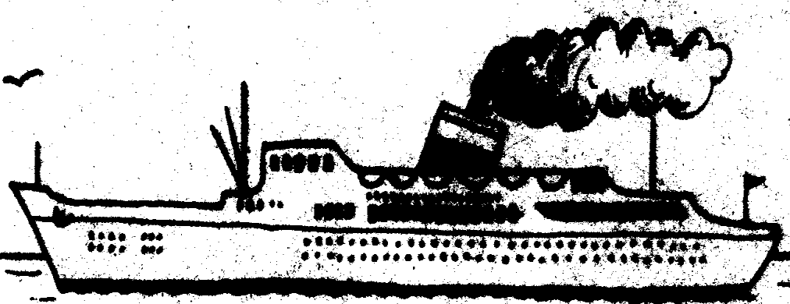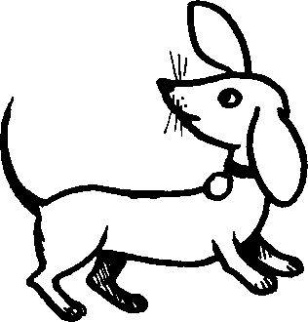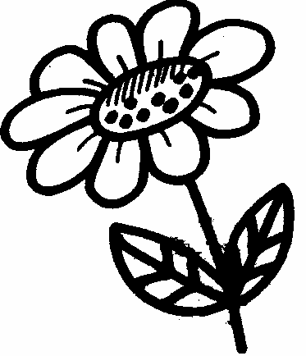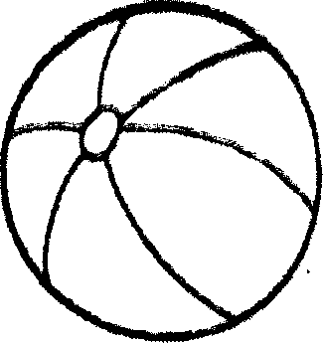

1 2 3 4 5