PRIČA PO NIZU SLIKA
NASLOV:______________________________
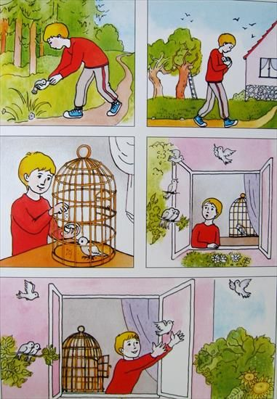
1.______________________________________________________________________________________________________________

2.______________________________________________________________________________________________________________

3.______________________________________________________________________________________________________________

4.______________________________________________________________________________________________________________

5.______________________________________________________________________________________________________________
GLAVNI LIKOVI:_________________________
SPOREDNI LIKOVI:_____________________________________________________________________
MJESTO RADNJE:_______________________
VRIJEME RADNJE:____________________________________________________________________

POUKA PRIČE:_______________________________________________________________________________________________________________________________________________

