ODGOJNO – OBRAZOVNO PODRUČJE: IZOBRAZBA U OBAVLJANJU POSLOVA

MOJA UREDNA PERNICA
ZADATAK: VAŠ JE ZADATAK DA OŠILJITE SVOJE OLOVKE I BOJICE KAKO BI VAŠA PERNICA BILA UREDNA I SPREMNA ZA ŠKOLU!
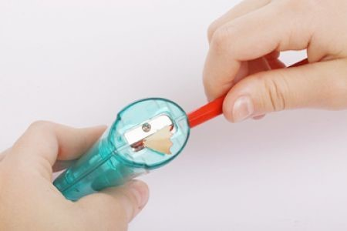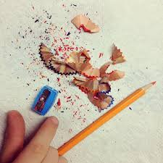

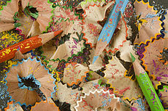
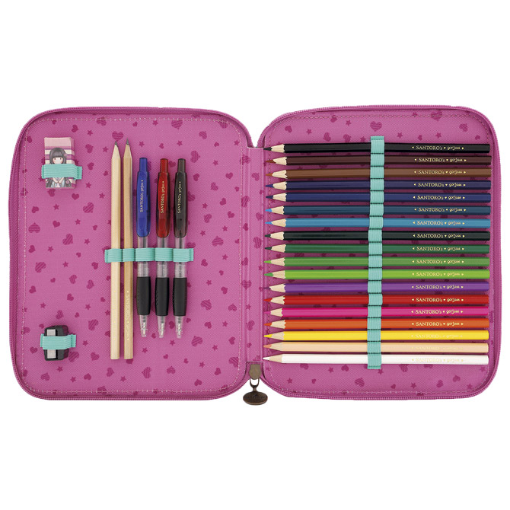

*Slike su uzete sa internetskih stranica:
https://www.babylandia.si/image/cache/catalog/slike_artiklov/product_image-3465-1-214x247.jpg
https://upload.wikimedia.org/wikipedia/commons/thumb/7/76/5481_Afiladura_1.jpg/230px-5481_Afiladura_1.jpg
https://lh3.googleusercontent.com/proxy/X2xxHQ3VgaPDL2B5EfsdaZx-KBYn6qHcMcCBYYcFHj1oaPoRrMuQvShvvibFGb7WX6rP0SJCownRCUYGFWyPNFrBtI5sfZZ5WcsEDAvTAINMUmXxXMFP
https://encrypted-tbn0.gstatic.com/images?q=tbn%3AANd9GcTYJLT859-vrjGx0ZVFDdL-3FlLvSKcwwsRgQ&usqp=CAU
https://mojkontakt.fajlovi.com/wp-content/uploads/2017/01/drvene-bojice-mogu-se-naci-u-cak-72-boje-900x600-20160208-20160224124611-f874cbd36c54d101f9614dc7c04f1787.jpg

