HRVATSKI JEZIK - PETAK 26.11.2020. AK,KH,MD
PROMOTRI SLIKE. OPIŠI SLIKE PREMA REDOSLIJEDU.

OSMISLI NASLOV PRIČE:__________________________________________________________
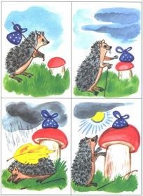

NAPIŠI PO JEDNU REČENICU ZA SVAKU SLIKU UZ POMOĆ UKUĆANA PISANIM SLOVIMA.
1._______________________________________________________

________________________________________________________

________________________________________________________

2._______________________________________________________

________________________________________________________

________________________________________________________

3._______________________________________________________

________________________________________________________

________________________________________________________

4._______________________________________________________

________________________________________________________

