**Napiši što je spojeno:**

**(1)**

baka

baka i luk

guma4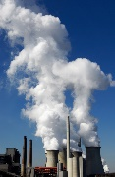

**______________________________**

**______________________________**

beba

kuka2lijapas4panj5jajanož3džip3dar3zid3ruž2mis4luk4dama3deva3buća2

**______________________________**

**______________________________**

**______________________________**

**______________________________**

**______________________________**

**______________________________**

**______________________________**

**______________________________**