ZADATAK:

1. DOBRO PROMOTRI SLIČICU I NAPIŠI RIJEČ NA CRTU PORED.

**osam2žaba3**

**____________**

**____________**

**____________**

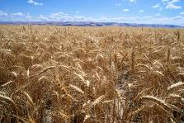**buća2zelje2janjekuća5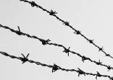ovan**

**____________**

**____________**

**____________**

**____________**

**____________**

**____________**

**____________**

**____________**

**____________**

**____________**

**krpa2kruh2iglakostključ4buba-maragrah2listdrvabrod2auto2**

**____________**

**____________**

**____________**

**____________**

**____________**

**____________**

**____________**

**_______________________**

**____________**

**____________**

**____________**

**____________**

**____________**

**____________**