POKAŽITE I IMENUJTE ŽIVOTINJE KOJE SPAVAJU ZIMSKI SAN.

[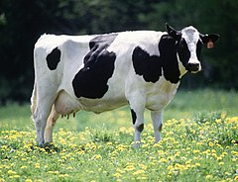](https://www.google.hr/url?sa=i&url=https://hr.wikipedia.org/wiki/Doma%C4%87e_govedo&psig=AOvVaw3TVYNwPbmyxhXte8NwVluv&ust=1603977137675000&source=images&cd=vfe&ved=0CAIQjRxqFwoTCKC5rtCu1-wCFQAAAAAdAAAAABAD) [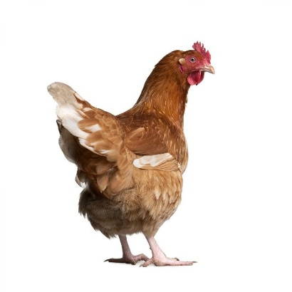](https://www.google.hr/url?sa=i&url=https://fatur.hr/trgovina/kokosi-nesilice-8tj/&psig=AOvVaw2y5YWarGCBSbMQA-QRKaqh&ust=1603977177320000&source=images&cd=vfe&ved=0CAIQjRxqFwoTCIiV1OSu1-wCFQAAAAAdAAAAABAD)

[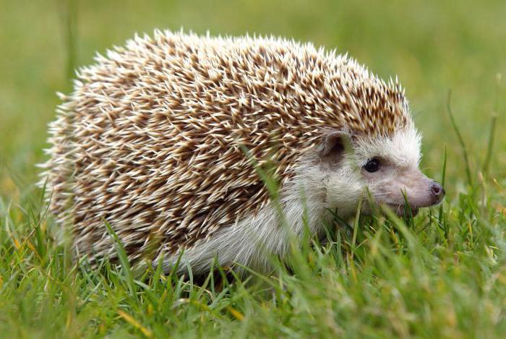](https://www.google.hr/url?sa=i&url=https://hr.puntomarinero.com/where-does-the-hedgehog-live/&psig=AOvVaw14-JDX0J_oX91ComtoqYrR&ust=1603977239223000&source=images&cd=vfe&ved=0CAIQjRxqFwoTCLiy0Iqv1-wCFQAAAAAdAAAAABAD) [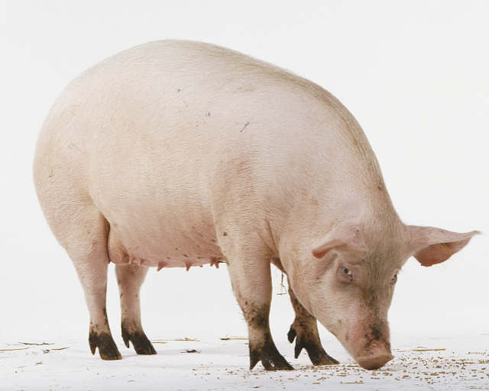](https://www.google.hr/url?sa=i&url=https://veterina.info/svinje&psig=AOvVaw2ETUj4oWTn6vB9uoY3Ma9U&ust=1603977465286000&source=images&cd=vfe&ved=0CAIQjRxqFwoTCJjRpPOv1-wCFQAAAAAdAAAAABAD)

[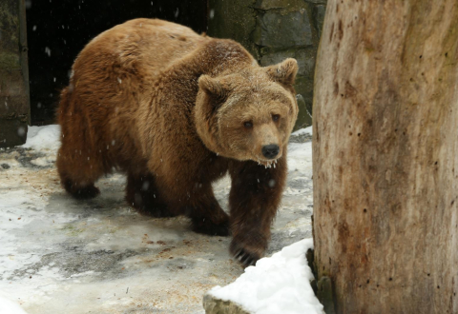](https://www.google.hr/url?sa=i&url=https://net.hr/danas/svijet/horor-u-bih-pucao-u-medvjeda-mislio-da-je-mrtav-ali-zivotinja-se-ustala-i-otkinula-mu-dio-noge/&psig=AOvVaw1pg8StYZRZZnQLApKFFDiJ&ust=1603977524015000&source=images&cd=vfe&ved=0CAIQjRxqFwoTCNjk8Jaw1-wCFQAAAAAdAAAAABAE) [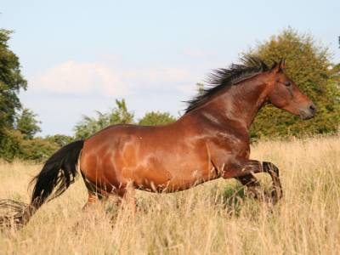](https://www.google.hr/url?sa=i&url=https://www.konji.hr/&psig=AOvVaw0wyulk_LTtvK6gMaCYbm5l&ust=1603977668272000&source=images&cd=vfe&ved=0CAIQjRxqFwoTCICUj9Ww1-wCFQAAAAAdAAAAABAD)

[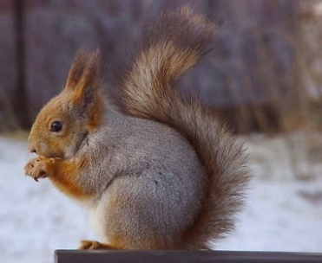](https://www.google.hr/url?sa=i&url=https://bs.wikipedia.org/wiki/Obi%C4%8Dna_vjeverica&psig=AOvVaw1gyZYfQJEYpNmNOhO6b5W4&ust=1603977778282000&source=images&cd=vfe&ved=0CAIQjRxqFwoTCNiCmoOx1-wCFQAAAAAdAAAAABAD) [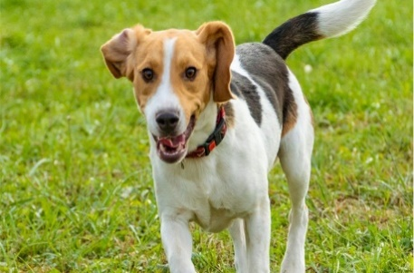](https://www.google.hr/url?sa=i&url=https://www.index.hr/clanak.aspx?id%3D2067428&psig=AOvVaw3e4LSfQKWxB3meOUVxyb_k&ust=1603977823887000&source=images&cd=vfe&ved=0CAIQjRxqFwoTCMiOtJqx1-wCFQAAAAAdAAAAABAD) [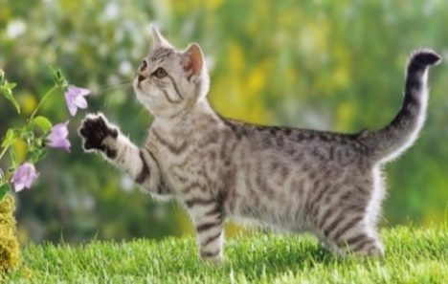](https://www.google.hr/url?sa=i&url=http://pixelizam.com/kako-i-zasto-macke-predu/&psig=AOvVaw38BF_Ue7393oeHhEI9sN60&ust=1603977883826000&source=images&cd=vfe&ved=0CAIQjRxqFwoTCICXvsKx1-wCFQAAAAAdAAAAABAD)

Izreži i zalijepi životinje koje spavaju zimski san. Pored slike napiši ime životinje.