[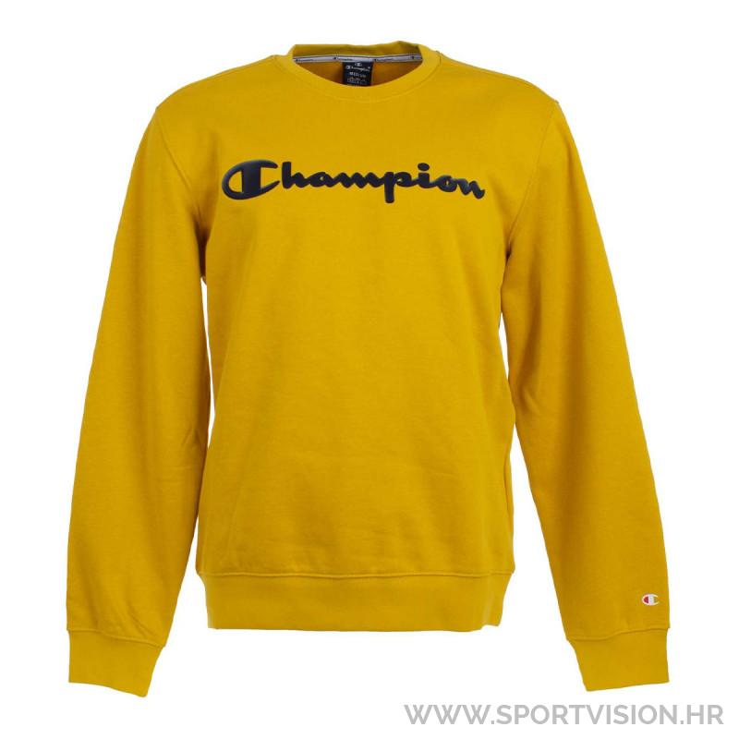](https://www.google.hr/url?sa=i&url=https://www.sportvision.hr/majice-bez-kragne/658444-champion-majica-dugih-rukava&psig=AOvVaw12yqOWA9j-MOwDvD0w2-uB&ust=1604956740771000&source=images&cd=vfe&ved=0CAIQjRxqFwoTCJjkkPjv8-wCFQAAAAAdAAAAABAD)

**MAJICA**