PETAK 11.12.2020. HRVATSKI JEZIK-AK,KH,MD- PROMATRAJ SLIKU, OPIŠI JU U NEKOLIKO REČENICA.
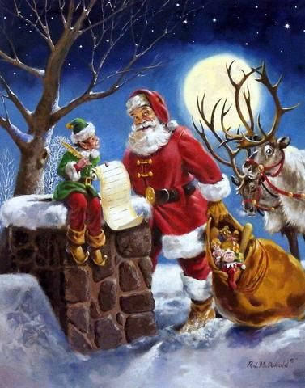
NAPIŠI 5 REČENICA O OVOJ SLICI:
1._______________________________________________________

________________________________________________________

2._______________________________________________________

________________________________________________________
3._______________________________________________________

________________________________________________________

4._______________________________________________________

________________________________________________________

5._______________________________________________________

________________________________________________________

