**DIJELOVI TIJELA**

**[](https://www.google.hr/url?sa=i&url=http%3A%2F%2Fdecijisnovi.com%2FdeloviTela&psig=AOvVaw0fd3k6Jiau-FJjgwulNLVm&ust=1611063723965000&source=images&cd=vfe&ved=0CAIQjRxqFwoTCPDq_qzOpe4CFQAAAAAdAAAAABAE)[](https://www.google.hr/url?sa=i&url=https%3A%2F%2Fwww.soyvisual.org%2Fnode%2F55962%2Flightbox%2Fnojs&psig=AOvVaw33Qs2FpDNokshmrL-nsK3q&ust=1611063840503000&source=images&cd=vfe&ved=0CAIQjRxqFwoTCKCO4drOpe4CFQAAAAAdAAAAABAI)**

**[](https://www.google.hr/url?sa=i&url=http%3A%2F%2Fwww.portaloko.hr%2Fclanak%2Fbolovi--u-nogama-ispod-koljena--uzroci-i-prva-pomoc%2F0%2F95196%2F&psig=AOvVaw2eh00Y7gkTL2YArjBxGHCZ&ust=1611064147110000&source=images&cd=vfe&ved=0CAIQjRxqFwoTCIj6s_fPpe4CFQAAAAAdAAAAABAR) [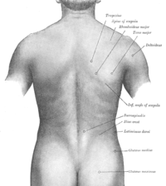](https://www.google.hr/url?sa=i&url=https%3A%2F%2Fhr.wikipedia.org%2Fwiki%2FLe%25C4%2591a&psig=AOvVaw22TR7x0sblnVGfiv8ssgcT&ust=1611063947210000&source=images&cd=vfe&ved=0CAIQjRxqFwoTCPjGqMvQpe4CFQAAAAAdAAAAABAl)**

**[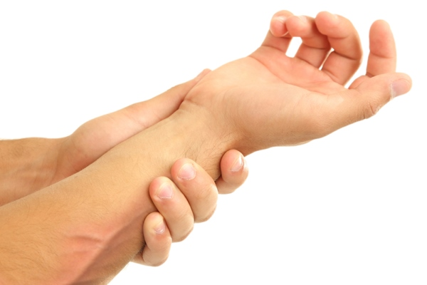](https://www.google.hr/url?sa=i&url=https%3A%2F%2Fhayat.ba%2Fovih-pet-dijelova-tijela-odaju-vase-godine%2F85801%2F2%2F&psig=AOvVaw2Bi-994Z7_4ykvoqUQNvYM&ust=1611064494444000&source=images&cd=vfe&ved=0CAIQjRxqFwoTCKCdopHRpe4CFQAAAAAdAAAAABAH)**

**POKAŽI NA SLICI: GLAVU, VRAT, TRUP, RUKE, NOGE**