**KARAKTERISTIKE PROLJEĆA 2**

 

**SUNČANO OBLAČNO**

 

**MAGLOVITO KIŠOVITO**

*SUNCE JAČE GRIJE.

*SNIJEG SE OTOPIO I POSTAJE SVE TOPLIJE.

*VRIJEME JE PROMJENLJIVO.

[](https://www.google.hr/url?sa=i&url=https://zoona.hr/zoonimljivosti/spava-ti-se-mozda-si-i-ti-zivotinja-koja-spava-zimski-san/&psig=AOvVaw0AFSylxSnvmtjwTyNjpzAS&ust=1614459067354000&source=images&cd=vfe&ved=0CAIQjRxqFwoTCICzqoG3iO8CFQAAAAAdAAAAABAJ)

*ŽIVOTINJE KOJE SPAVAJU ZIMSKI SAN POČINJU SE BUDITI.

[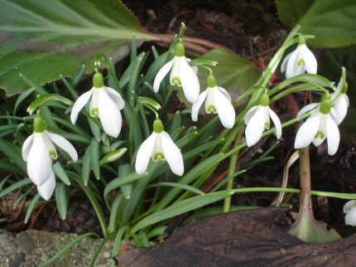](https://sites.google.com/site/cvijece10)[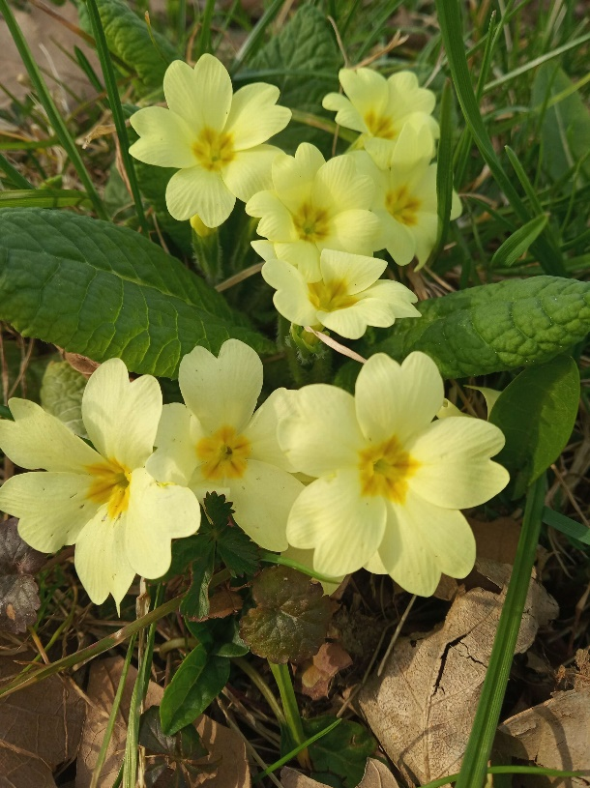](https://www.google.hr/url?sa=i&url=http://www.essenceofcroatia.com/hr/blog/340-10-najpoznatijih-vjesnika-proljeca&psig=AOvVaw0RmsuEJG3V-Qp4DYd-IWPi&ust=1614459209404000&source=images&cd=vfe&ved=0CAIQjRxqFwoTCIj0ydW3iO8CFQAAAAAdAAAAABAJ)

VISIBABA JAGLAC

*NA LIVADAMA I U ŠUMI RASTE PRVO PROLJETNO CVIJEĆE. ZOVU SE VIJESNICI PROLJEĆA.

[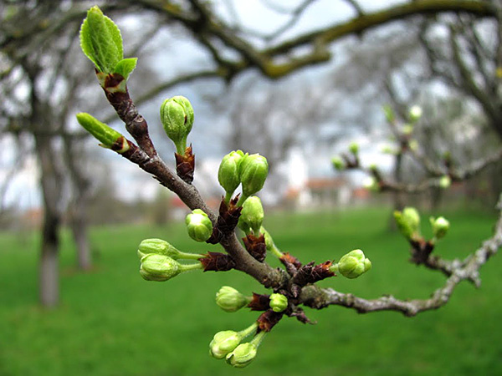](https://www.google.hr/url?sa=i&url=https://portalosuma.com/2016/05/31/gemoterapija-lijecenje-uz-pomoc-mladica-i-pupoljaka-drveca/&psig=AOvVaw15rZEse_2QNDCfUS9UPSY_&ust=1614459811799000&source=images&cd=vfe&ved=0CAIQjRxqFwoTCLidrtK5iO8CFQAAAAAdAAAAABAD)

*NA GRANAMA DRVEĆA POČINJU NICATI PRVI PUPOLJCI LIŠĆA.

Ako ste u mogućnosti izađite s djetetom u šetnju. Potičite ga da promatra okolinu. Pitajte ga koje godišnje doba završava u mjesecu ožujku, a koje počinje. Kakvo je vrijeme danas. Ako imate u blizini pokažite mu neku granu na stablu/grmu koje je počelo pupati, visibabu i jaglac. Zajedno pročitajte tekst (dijete neka gleda slike). Možete nekoliko puta.

PITANJA: Pročitajte djetetu pitanja, pokažite slike i pročitajte ponuđene odgovore. Dijete neka odabere točan odgovor od svih ponuđenih i odgovori jednostavnom rečenicom.

1.Kakvo je vrijeme u godišnje doba proljeće? (promjenjivo)

2.Što znači kada je vrijeme promjenjivo? (to znači da se često mijenja)

3. Pokaži na slici vremenske prilike u proljeće.

[](https://www.google.hr/url?sa=i&url=https%3A%2F%2Frtvzivinice.tv%2Futicaj-vremena-na-zdravlje-ljudi%2F&psig=AOvVaw0xJo1rbCs783ZmmGt0tpPp&ust=1614782233518000&source=images&cd=vfe&ved=0CAIQjRxqFwoTCMiNgObqke8CFQAAAAAdAAAAABAT)4. Životinje koje spavaju zimski san u proljeće počinju se:

[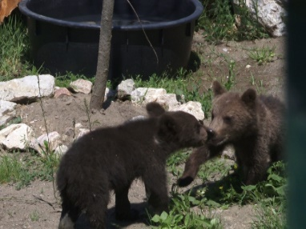](https://www.google.hr/url?sa=i&url=https%3A%2F%2Fbhportal.ba%2Fmedvjedici-sema-i-pepo-odusevili-posjetitelje-zoo-vrta-bingo-foto%2F&psig=AOvVaw2irzRfKFv-XnpafgH-4GPh&ust=1614783038007000&source=images&cd=vfe&ved=0CAIQjRxqFwoTCJi_mO3tke8CFQAAAAAdAAAAABAF) [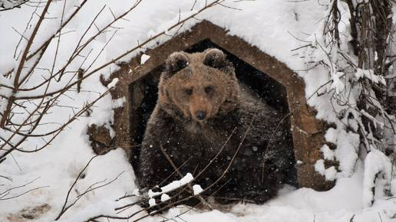](https://www.google.hr/url?sa=i&url=https%3A%2F%2Fwww.24sata.hr%2Ftagovi%2Fzimski-san-82719&psig=AOvVaw2OQXEaapkOXsNqlH2NQH5B&ust=1614783334741000&source=images&cd=vfe&ved=0CAIQjRxqFwoTCMiPt__uke8CFQAAAAAdAAAAABAK) [](https://www.google.hr/url?sa=i&url=https%3A%2F%2Fhr.womanexpertus.com%2Fchem-pitayutsya-medvedi-ratsion-belogo-i-burogo-medvedej-v-prirode%2F&psig=AOvVaw3Lbpt2cmNremLu2D7GCy6F&ust=1614783206086000&source=images&cd=vfe&ved=0CAIQjRxqFwoTCKiL38Xuke8CFQAAAAAdAAAAABAJ)

IGRATI BUDITI JESTI

5. Na granama drveća počinju nicati prvi pupoljci:

[](https://www.google.hr/url?sa=i&url=https%3A%2F%2Fwww.agroklub.com%2Fsortna-lista%2Fpovrce%2Frajcica-169%2F&psig=AOvVaw3x7yARGVO6Px_Ttpjt58Im&ust=1614783882450000&source=images&cd=vfe&ved=0CAIQjRxqFwoTCICKsvDwke8CFQAAAAAdAAAAABAD) [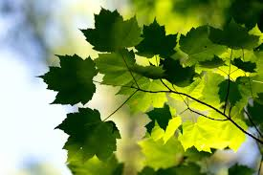](https://www.google.hr/url?sa=i&url=https%3A%2F%2Fpixnio.com%2Fhr%2Fkrajolici%2Flisce%2Fflore-gren-list-ekologija-priroda-drvo-suma-biljka-lisce-grane&psig=AOvVaw3mXrrEzJaEDrBovVoqoE0m&ust=1614783924397000&source=images&cd=vfe&ved=0CAIQjRxqFwoTCOCRg6Xxke8CFQAAAAAdAAAAABAK) [](https://www.google.hr/url?sa=i&url=https%3A%2F%2Fwww.ljepotaizdravlje.ba%2Fzdravlje%2Fishrana%2Fzdrava-hrana%2Frazlozi-za-svakodnevno-konzumiranje-banana&psig=AOvVaw0jGCPTpRzogdOLKXMi1CYC&ust=1614784046372000&source=images&cd=vfe&ved=0CAIQjRxqFwoTCIj41L7xke8CFQAAAAAdAAAAABAD)

RAJČICA LIŠĆA BANANA

6. Na livadama i u šumi raste prvo proljetno:

[](https://www.google.hr/url?sa=i&url=https%3A%2F%2Fvrana.hr%2Fsvjeze-bijelo-grozde%2F&psig=AOvVaw0ySEkJSuulEQhoUhxgIxa2&ust=1614784220140000&source=images&cd=vfe&ved=0CAIQjRxqFwoTCKjt4JLyke8CFQAAAAAdAAAAABAD)[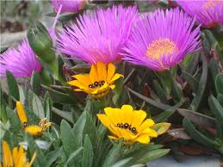](https://www.google.hr/url?sa=i&url=http%3A%2F%2Fwww.cvijet.info%2Fslike_cvijeca%2Fvrtno_cvijece%2Fvrtno_cvijece%2F14879.aspx&psig=AOvVaw10TVS7832Mz4xnaU0DPEcl&ust=1614784282825000&source=images&cd=vfe&ved=0CAIQjRxqFwoTCNDezLDyke8CFQAAAAAdAAAAABAV)[](https://www.google.hr/url?sa=i&url=https%3A%2F%2Fwww.agroklub.com%2Fsortna-lista%2Fpovrce%2F&psig=AOvVaw1uXh0sLw7a3DPExb9KSD2N&ust=1614785501009000&source=images&cd=vfe&ved=0CAIQjRxqFwoTCMj12fr2ke8CFQAAAAAdAAAAABAD)

GROŽĐE CVIJEĆE POVRĆE

7. Prvo proljetno cvijeće zovu se vjesnici proljeća, pokaži ih na slici.

[](https://www.google.hr/url?sa=i&url=https%3A%2F%2Fwww.cutecolor.hr%2Fproizvod%2Fizrezivac-za-cvijece-veiners-tulipan%2F&psig=AOvVaw2-4bjZxAR9roGcaGixca4F&ust=1614785668135000&source=images&cd=vfe&ved=0CAIQjRxqFwoTCPC--MP3ke8CFQAAAAAdAAAAABAD)[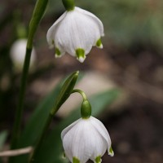](https://www.google.hr/url?sa=i&url=https%3A%2F%2Fwww.plantea.com.hr%2Fproljetni-drijemovac%2F&psig=AOvVaw3r7GFjP2MHZ4tD43XtjTol&ust=1614785748432000&source=images&cd=vfe&ved=0CAIQjRxqFwoTCOjGmuv3ke8CFQAAAAAdAAAAABAI)[](https://www.google.hr/url?sa=i&url=https%3A%2F%2Fwww.mamioaza.sk%2Fdetail%2Fumela-kvetina-ruza-cervena-60-cm&psig=AOvVaw0ztVRjzkowQxMYOb2Xojan&ust=1614785792625000&source=images&cd=vfe&ved=0CAIQjRxqFwoTCKjutoD4ke8CFQAAAAAdAAAAABAJ)

TULIPAN ZVONČIĆ RUŽA

[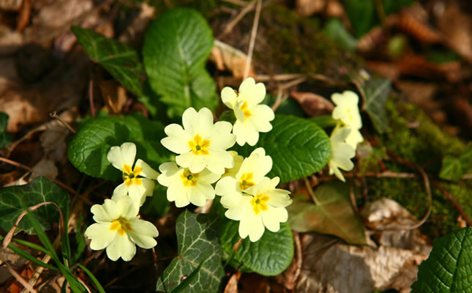](https://www.google.hr/url?sa=i&url=https%3A%2F%2Fwww.narodnilijek.com%2Fweb%2Fjaglac%2F&psig=AOvVaw0wARIKk0oGbsbNJetql0tu&ust=1614785892760000&source=images&cd=vfe&ved=0CAIQjRxqFwoTCLjM77H4ke8CFQAAAAAdAAAAABAJ)[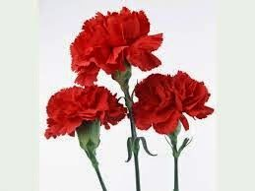](https://www.google.hr/url?sa=i&url=https%3A%2F%2Fwww.pinterest.com%2Fpin%2F535224736940806157%2F&psig=AOvVaw3gMK35q-3Ij8QQoNHXOdv7&ust=1614785994357000&source=images&cd=vfe&ved=0CAIQjRxqFwoTCPipqeH4ke8CFQAAAAAdAAAAABAJ)[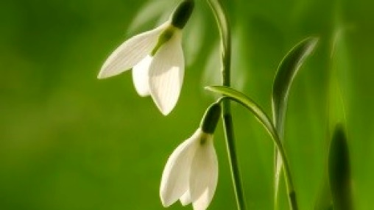](https://www.google.hr/url?sa=i&url=https%3A%2F%2Fwww.agroklub.com%2Fhortikultura%2Fznate-li-koliko-visibaba-smijete-ubrati%2F8919%2F&psig=AOvVaw0zLa4P2CiXQcr-h7_y94QS&ust=1614786042449000&source=images&cd=vfe&ved=0CAIQjRxqFwoTCNj76_b4ke8CFQAAAAAdAAAAABAD)

JAGLAC KARANFIL VISIBABA