PETAK,30.4.2021. HRVATSKI JEZIK-AK,KH,MD
PROMATRAJ SLIKE PO REDU I OPIŠI IH.
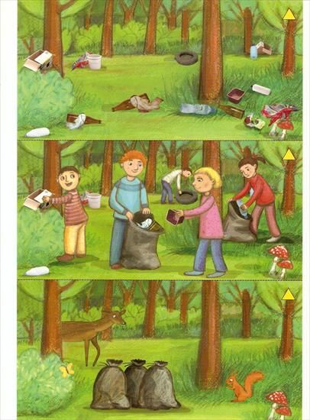
NAPIŠI PO JEDNU REČENICU ZA SVAKU SLIKU, OPIŠI JU.
1._________________________________________________

__________________________________________________

2._________________________________________________

__________________________________________________

3._________________________________________________

__________________________________________________

