Križaljka

|  |  |  |  |
| --- | --- | --- | --- |
| **1** |  |  |  |
|  |  |  |  |
| **3** |  |  |  |  |  |  | |
|  |  |  |  |
|  |  |  |  |  |  |  |

5**)**

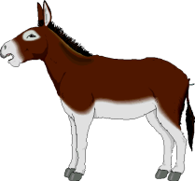

4

2) 5



4)

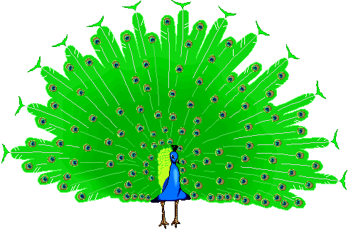 3) 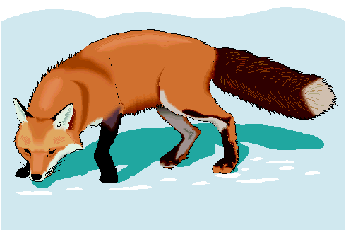

1. 