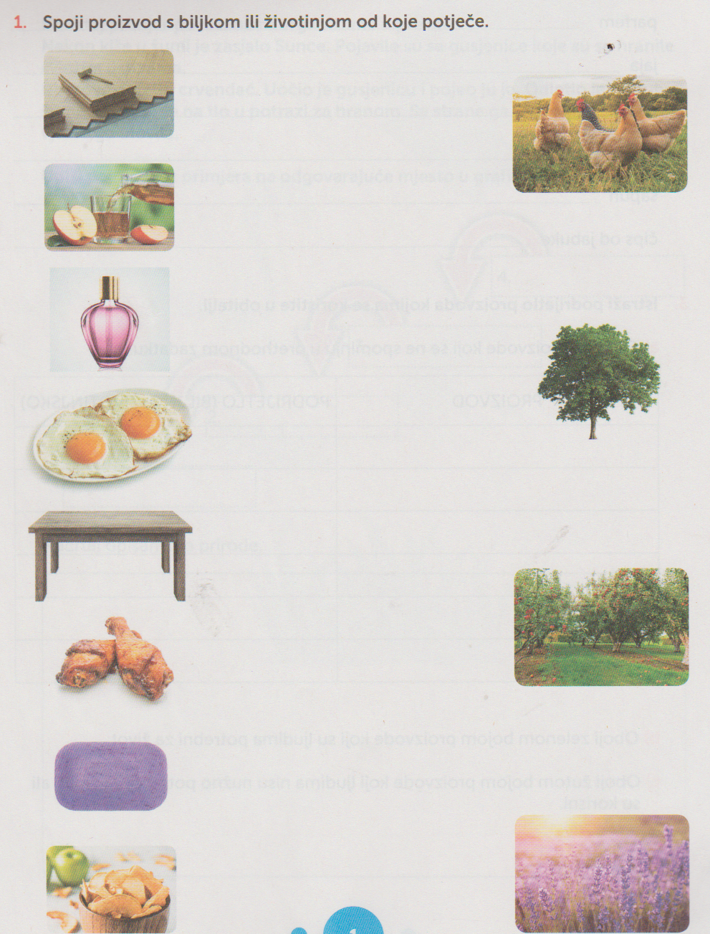

ISTRAŽI:

1.Koje ljekovito bilje raste u tvom zavičaju?
_____________________________________________________________________________________________________________________________________________________

2.Koje domaće životinje uzgajaju stočari radi dobivanja mlijeka?
_________________________________________________________________________________________________________________________________

3.Što se proizvodi od mlijeka u tvome zavičaju?
___________________________________________________________________________________________________________________________________________________________________________________________________

