ODGOJNO – OBRAZOVNO PODRUČJE: SKRB O SEBI
ZADATAK: POMOGNITE POMESTI PODOVE I USISATI TEPIHE U VAŠOJ KUĆI!

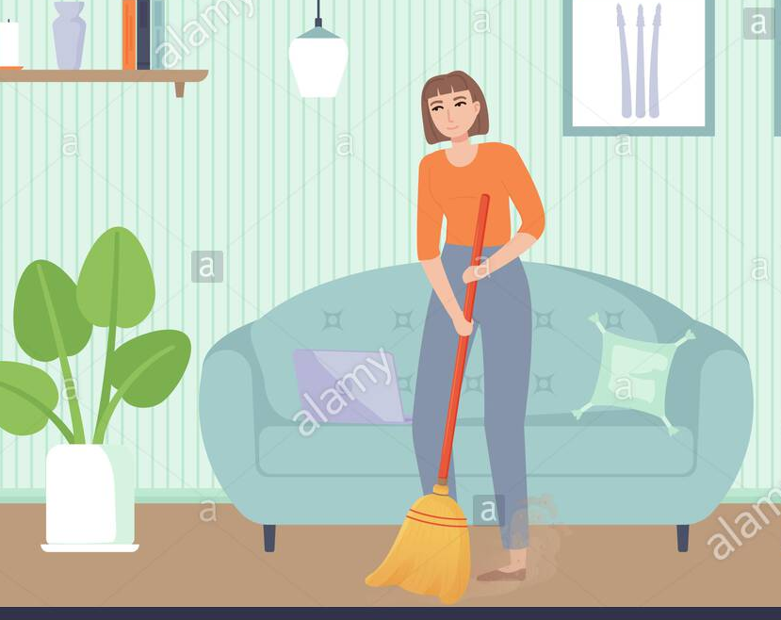

* Slike su uzete s internetskih stranica:
https://cdn1.vectorstock.com/i/1000x1000/52/35/woman-cleaning-floor-with-vacuum-cleaner-vector-13455235.jpg
https://previews.123rf.com/images/topvectors/topvectors1709/topvectors170900247/85577035-young-smiling-man-cleaning-the-floor-with-vacuum-cleaner-house-husband-working-at-home-vector-illust.jpg

