PETAK,14.5.2021. HRVATSKI JEZIK-AK,KH,MD
PROČITAJ PJESMICU NEKOLIKO PUTA. ODGOVORI NA PITANJA.
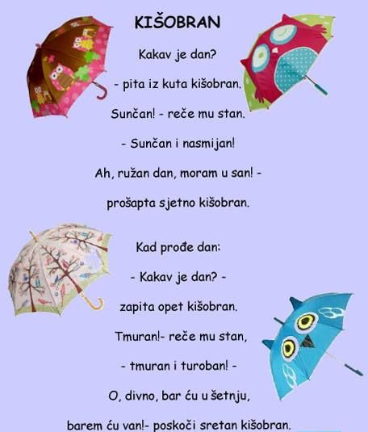

- GDJE STOJI KIŠOBRAN U STANU?
__________________________________________________
__________________________________________________
- TKO RAZGOVARA U PJESMI?
__________________________________________________
__________________________________________________

- KAKVO JE BILO VRIJEME PRVI DAN?
__________________________________________________
__________________________________________________
- ZAŠTO JE KIŠOBRANU SUNČANI DAN RUŽAN?
__________________________________________________
__________________________________________________
- KAKVO JE BILO VRIJEME DRUGI DAN?
__________________________________________________
__________________________________________________

- ČEMU SE RADOVAO KIŠOBRAN TADA?
__________________________________________________
__________________________________________________
7.NACRTAJ I OBOJI SVOJ KIŠOBRAN:

