**JA VOLIM LJETO.**

**LJETI IDEM NA MORE.**

**NA MORU SE KUPAM.**

[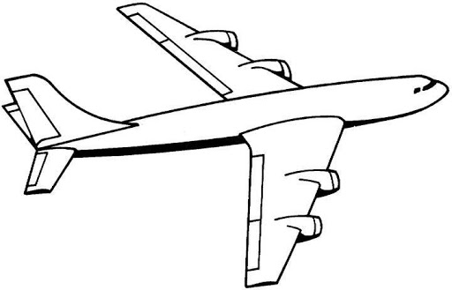](https://www.google.hr/url?sa=i&url=http://www.bojanke.net/razlicito/bojanke_aviona/index.html&psig=AOvVaw3gevcBiahPftD7-irs_UB7&ust=1586185212406000&source=images&cd=vfe&ved=0CAIQjRxqFwoTCPCImcnG0egCFQAAAAAdAAAAABAD)

[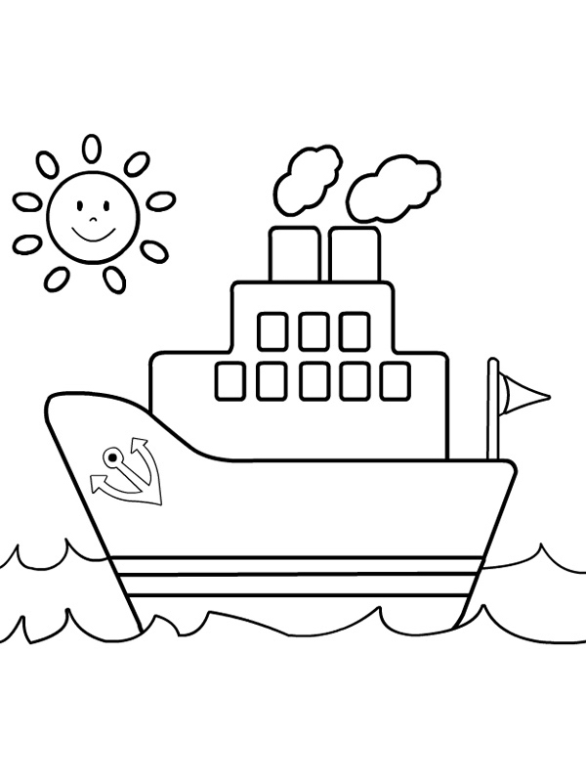](https://www.google.hr/url?sa=i&url=https://www.bojanke.com/brodovi.htm&psig=AOvVaw3moAocLAguj1GHKlmvtlPr&ust=1586185269518000&source=images&cd=vfe&ved=0CAIQjRxqFwoTCMi8q-3G0egCFQAAAAAdAAAAABAD)

[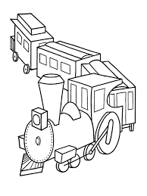](https://www.google.hr/imgres?imgurl=http://www.bojanke.com/bojanke/vozovi_01.jpg&imgrefurl=https://www.bojanke.com/vozovi.htm&tbnid=VfuoDAdgcj6JqM&vet=10CAUQxiAoBGoXChMIoKHOosfR6AIVAAAAAB0AAAAAEAc..i&docid=MBE3GGi3NKNaHM&w=600&h=800&itg=1&q=bojanka%20vlak&ved=0CAUQxiAoBGoXChMIoKHOosfR6AIVAAAAAB0AAAAAEAc)